British Forces School Naples
Remote Learning Policy and Guidance
December 2020

Policy Contents:
Page | Content
2 | Policy Contents
2 | Policy Aims
3 - 5 | Teacher Roles and Responsibilities
5 - 6 | LSA Roles and Responsibilities
6 | Subject Leader Roles and Responsibilities
6 | Senior Leaders Roles and Responsibilities
7 | Designated Safeguarding Leader Roles and Responsibilities
7 | ICT Administrator Roles and Responsibilities
7 - 8 | Pupils and Parents Roles and Responsibilities
8 | Who to Contact
8 -9 | Data Protection
9 | Safeguarding
9 | Policy Updates
10 - 13 | Appendix A  Individuals in Isolation
14 - 17 | Appendix B  Setting up eSchools
18 - 19 | Appendix C  eSchools Contents Guidance

1. Aims
During the Covid-19 pandemic BFS Naples expects some disruption to the school routine by individual pupil, class, part-school or whole-school isolation. As a school, we have considered the DFE guidance for home learning and have a strategy in place to facilitate home learning if and when the need arises.

‘Where a class, group or small number of pupils need to self-isolate, or there is a local lockdown requiring pupils to remain at home, we expect schools to have the capacity to offer immediate remote education. Schools are expected to consider how to continue to improve the quality of their existing offer and have a strong contingency plan in place for remote education provision by the end of September. This planning will be particularly important to support a scenario in which the logistical challenges of remote provision are greatest, for example where large numbers of pupils are required to remain at home.’
This remote learning policy for staff aims to:
- Ensure consistency in the approach to remote learning for pupils who aren’t in school;
- Set out expectations for all members of the school community with regards to remote learning;
- Provide appropriate guidelines for data protection;
- Ensure pupils unable to attend school remain fully included within the school community;
- Continue to ensure that every child receives the best education the school can provide them;
- Ensure that remote education is integrated in the curriculum so it is an essential part of the school curriculum, alongside classroom teaching, or in the case of a local lockdown.
2. Roles and responsibilities
2.1 Teachers
When providing remote learning, teachers must be available between 08:15 – 15:15 on their working days.If they’re unable to work for any reason during this time, for example due to sickness or caring for a dependent, they should report this using the normal absence procedure.

When providing remote learning, teachers are responsible for:
Setting work
For whole school or partial school closures, teachers will provide learning for their current class. The learning will be set on eSchools and differentiated as appropriate. Pre-recorded videos will be uploaded to support children’s learning. The DfE requires that between three and five hours of learning is set each day depending on the age of the children.

KS1 and KS2
English – including elements of SPAG and Phonics as appropriate | 60 - 90 minutes each day
Mathematics – including appropriate extension activities and challenge | 60 - 90 minutes each day
Topic activities which may be extened over a number of days. This should include Science, Geography, History and all other Foundation Subjects | Work will be set twice a week for KS1 and three times a week for KS2
Reading – Strive for 5 should be promoted and rewarded with House Points. All children should be expected to record what they have read each day. Children should also be encouraged to use Bug Club, Oxford Owl or their own books at home. | 15 minutes minimum each day
EYFS
A phonics session | Daily
A Literacy activity

A Maths activity

A topic activity linked to Understanding the World; Personal, Social and Emotional Development; Expressive Arts and Design, Physical Development and/or Communication and Language.

The above will be set as a daily ‘project’ on eSchools. The learning will be published daily on eSchools no later than 6pm on the evening prior to the days learning to allow parents to print at home should they require.

If the whole school is closed, this will be supplemented with the whole school weekly Expressive Arts challenge, PSHE challenge and Physical challenge set by LSAs and published on eSchools which children can access at anytime during the week. Also, all classes will have access to a weekly Italian language lesson led by Keila Scarpato and published as videos and tasks on eSchools. This offer may not be available during a partial school or bubble closure, depending on staffing level.

Teachers will ensure pupils and parents are also regularly made aware, via Zoom sessions and their class dashboard on eSchools, that they have additional access to the online platforms Times Tables Rockstars, Bug Club, My Maths, Education City, Espresso and Oxford Owl as well as free online resources such as Phonics play, BBC Bitesize, Oak Academy, Maths Frame, Spelling Frame etc. to supplement their daily learning should pupils/parents require additional tasks.

In addition to setting work each day, teachers will:

- Teachers will liaise with parents to provide printed packs that can be collected from the school on a weekly basis.
- Teachers will introduce the learning daily via a morning Zoom and a video will be uploaded for English and Maths to further explain for those pupils who are not able to attend the morning Zoom.
- All teachers will also offer and end of the day/feedback Zoom.
- Teachers are available all day to offer group/individual support via Zoom or messages on eSchools should it be required.
- If setting learning for an individual in isolation, the class teacher will publish the learning for the week using White Rose Maths and the Oak Academy as a basis (see Appendix A for an example). The work will be published to the individual child via eSchools. Children can upload their completed tasks on eSchools.

Providing feedback
- Pupils/parents are expected to upload completed learning to eSchools. All teachers will ensure that they create a submission of learning tab on the daily projects page to allow pupils/parents to do this.
- All completed tasks will be acknowledged by the class teacher. Pupils can expect more detailed feedback for English and Maths via a message received within 24 hours of the submission of their learning. Feedback will be age appropriate. House points may be awarded to celebrate achievement.
- Some learning will be self-assessed during zoom sessions and may not need as detailed feedback however, all learning will be commented on by the teacher for motivational purposes and general improvement.

Keeping in touch with pupils and their parents

- In the case of a national/local lockdown or the closure of a complete bubble, teachers will hold a morning registration Zoom. A daily register will be taken and the completed register forwarded to the HT at the end of the week.
- If a child has not attended two consecutive registration sessions, or failed to message/submit learning on two consecutive days, the class teacher will attempt to make contact parents via email to provide additional support. The class teacher is to copy the HT into this email. If no contact has been made by the fourth day, a member of the SLT will contact parents directly..
- Staff are not expected to answer emails or messages on eSchools from parents and pupils outside the school’s core hours of work – 08.15 – 17.00. Teachers should aim to answer messages within 24 hours of receiving them unless they are received over the weekend or after 15:00 on Friday.
- Any complaints or concerns shared by parents and pupils should be forwarded on to the SLT, even if being addressed initially by the class teacher (as per the complaints procedure).
- Behavioural and Safeguarding concerns should be recorded using MyConcern and will be followed up by the SLT.

Attending virtual meetings with staff, parents and pupils:
All school policies are expected to be adhered to including maintain the schools dress code and staff code of conduct. All staff are required to be in a location which avoids background noise, ensuring there is nothing inappropriate in the background.

2.2 Learning Support Assistants
When assisting with remote learning, teaching assistants must be available between 08:15 and 15:15. If they’re unable to work for any reason during this time, for example due to sickness or caring for a dependent, they should report this using the normal absence procedure.

LSAs will support our pupils by:
- By engaging with them via the class daily Zoom meetings
- Leading with home learning challenges including PawPrints challenges and weekly art, physical and PSHE challenges.
- By liaising with class teachers to support planning and resourcing differentiated learning
- Delivering interventions or small group work remotely if required, ensuring safeguarding protocols are met.
- Attending virtual meetings with teachers, parents and pupils:
- All school policies must be adhered to.
- All are expected to maintain the schools dress code.
- They are required to be in a location where they avoid areas with background noise, there should be nothing inappropriate in the background.

If the usual class learning support assistants are working in school, children will be allocated an LSA’s to work with remotely.

2.3 Subject leaders
Alongside their teaching responsibilities, subject leads are responsible for:
- Considering whether any aspects of the subject curriculum need to change to accommodate remote learning
- Working with teachers teaching their subject remotely to make sure all the learning set is appropriate and consistent
- Working with other subject leads and senior leaders to make sure the learning set remotely across all subjects is appropriate and consistent, and deadlines are being set an appropriate distance away from each other
- Monitoring the remote learning set by teachers in their subject
- Alerting teachers to resources they can use to teach their subject remotely

2.4 Senior leaders
Senior Leaders are responsible for:
- Co-ordinating the remote learning approach across the school.
- Monitoring the welfare of all pupils and staff.
- Monitoring the effectiveness of remote learning.
- Monitoring the security of remote learning systems, including data protection and safeguarding considerations.
- If the class teacher is unwell and unable to lead remote learning, then the Senior Leadership team will take direct responsibility for this. If this is the case, home learning provision and systems may need to be adapted so that school leaders can continue to manage their leadership roles whilst also providing remote learning for the class.

2.5 Designated Safeguarding Lead
The DSL is responsible for:
- Addressing all Safeguarding concerns, including those related to Remote Learning (Please refer to Child Protection and Safeguarding Policy).
- Ensuring staff are only communicating with pupils and parents using the approved school channels.
- If personal phone calls or individual Zoom meetings are made, keep a record of the time and date of these and ensure staff are aware that a parent should be with the child at all times. Attend these meetings as required.
- Ensuring all staff involved in the delivery of remote education online are aware that the same principles set out in the school’s code of conduct policy apply.

2.6 ICT Administrator
ICT Administrator is responsible for:
- Ensuring that all systems used to set and collect learning, work and function correctly.
- Helping staff and parents with any technical issues they’re experiencing.
- Reviewing the security of remote learning systems and flagging any data protection breaches to the SLT.
- Assisting pupils and parents with accessing the internet, devices or online learning platform and resources.
- Ensuring all pupils and staff have passwords and the appropriate access rights to the online learning platforms and online resources accessed during home learning.
- Ensuring parents of all new pupils sign the appropriate consents for accessing online learning including permission to attend Zoom meetings.

2.7 Pupils and parents
Staff can expect pupils learning remotely to:
- Be contactable during the school day – although they may not always be in front of a device the entire time.
- Do their best to complete their learning to the deadline set by teachers and submit via eSchools.
- Follow normal school rules and procedures particularly during group calls and Zoom meetings.
- Seek help if they need it, from teachers or teaching assistants, to enable them to complete all set tasks.
- Alert parents and teachers if they’re not able to complete learning or are having difficulty.

Staff can expect parents with children learning remotely to:
- Engage with school in terms of their child’s learning and where possible support home learning.
- Ensure their child does their best to completes tasks set in conjunction with support from school.
- Make the school aware if their child is sick or otherwise can’t complete work.
- Ensure pupils attend all morning registration slots and make teachers aware if this is not possible.
- Proactively seek help from the school if they or their child/ren need it.
- Be respectful when making any complaints or concerns known to staff.
3. Who to contact
If staff have any questions or concerns about remote learning, they should contact the following individuals:
- Issues in setting work, behaviour, pupil or parent engagement, work load or well-being – contact the SLT – Rebecca Robinson or Leanne Wortley
- Issues with IT, including passwords and use of online platforms – contact the ICT Administrator- Gareth Homer
- Concerns about data protection – contact the SLT and ICT Administrator Rebecca Robinson/Leanne Wortley and Gareth Homer
- Concerns about safeguarding or vulnerable families – contact to the DSL – Rebecca Robinson
- Concerns about children with identified SEND – contact the SENDCo – Leanne Wortley

4. Data protection
4.1 Accessing personal data
When accessing personal data for remote learning purposes:
- All teachers and members of the senior leadership team have password protected access to BROMCOM, Target Tracker, Teams, Outlook 365 and eSchools.
- Safeguarding information and reporting systems can be accessed at any location using MyConcern.
- At BFS Naples, teachers and SLT have access to school-owned and encrypted laptops as an additional security measure and school iPads if required.
- All staff have access to Office 365 Accounts which can be accessed from any device. Dual factor authentication is installed for all staff.
- Photographs of children’s completed work is stored on eSchools or can be stored on Teams if emailed.
- Staff have all received, read and understood Acceptable Use Policies to ensure their understanding of processing this type of data.

4.2 Processing personal data
Staff are reminded to collect and/or share as little personal data as possible online. When sending group emails to parents, staff are reminded to BCC the email addresses of all parents.

4.3 Keeping devices secure
All staff members will take appropriate steps to ensure their devices remain secure. This includes, but is not limited to:

- Keeping the device password-protected – strong passwords are at least 8 characters, with a combination of upper and lower-case letters, numbers and special characters (e.g. asterisk or currency symbol)
- Ensuring the hard drive is encrypted – this means if the device is lost or stolen, no one can access the files stored on the hard drive by attaching it to a new device
- Making sure the device locks if left inactive for a period of time
- Not sharing the device among family or friends
- Ensuring all antivirus and anti-spyware software installed is updated.
- Keeping operating systems up to date – always install the latest updates
5. Safeguarding
All Safeguarding procedures should be followed. Any concerns should be recorded on My Concern immediately and a member of the SLT should also be informed.
6. Policy Updates
This policy will be reviewed termly.

Appendix A – An Individual in isolation

Home Learning Resources – Year 6 Week One
We encourage all parents to work with their children to enable them to continue to make progress during this unexpected time away from school. We would recommend where possible that each child completes at least fifteen minutes reading, an English session and a maths session each day. There are also spelling sessions, topic sessions (Science, History, Geography or RE) and PSHE sessions to complete during the week. There is also a listed of suggested optional activities that could be completed.
Daily Reading
Continue to strive for five and record on the reading record sheet attached. It would be great if you can discuss with an adult what you have read and they can ask questions to ensure you have understood what you are reading. You can discuss the characters, setting and plot, make predications and explain your reasoning.

You may continue to read a book that you are enjoying from home or you can access one of the texts available on Bug Club or Oxford Owl. Please contact the school office naples.ictadmin@modschools.org if you cannot find your child’s personal log on details.
English
Our topic this term is ‘A Child’s War’ and is based on the experiences of evacuees during World War II. You can access the activities for your English work by visiting:
www.thenational.academy
Click on ‘lessons’ followed by ‘subjects’ and then ‘show year groups. Select ‘Year 6’, ‘English’ followed by ‘units’ and then find the unit ‘Goodnight Mr Tom by Michelle Magorian’.
This week you will be focusing on making inferences about characters. There are 5 lessons in this unit:
Lesson One: To activate prior knowledge and consider the historical context
In this lesson, the children will look at an extract from a newspaper article. They will think about what they already know, what they can infer and generate questions to help reflect upon what they don't yet know.
Lesson Two: To read a recount and answer retrieval and inference based questions
In this lesson, the children will place World War II on a timeline and be taught some subject-specific vocabulary. They will then read a first-hand account from a Blitz survivor and answer a range of inference and retrieval questions. The children will also have to reflect upon the type of question they are being asked.
Lesson Three: To understand the key information in a text and consider the author’s perspective In this lesson, the children will re-read the text they read previously and be guided to find the key information; they will also be guided to reflect upon the author's experience as they read. The lesson culminates with a writing opportunity which will help the children understand that reading helps them understand an entirely different life while building their ability to empathise.
Lesson Four: To read a new text and consider the author’s use of language
In this this lesson, the children will read a new account of a Blitz survivor and look at some of the language used to help them build comprehension. They will also make some brief comparisons between the two texts.
Lesson Five: To consider how reading can provide people with a way of learning new things In this lesson we will review everything we have learnt from reading the survivors' stories. The children will then make a mind map showing what the book they are currently reading or have recently read is teaching them. Finally, the teacher will suggest books the children might like to read if they are interested in learning more about WW2.

Try to complete one of the sessions each day. Record any responses in your writing book. Remember to write the long date and Learning Intention before you begin any tasks.

Spellings
You can access the activities for your spelling work by visiting:
www.thenational.academy
Click on ‘lessons’ followed by ‘subjects’ and then ‘show year groups’. Select ‘Year 6’ followed by ‘units’ and then find the unit title ‘homophones’ Try to complete lesson one on Monday and lesson Two on Friday, as this will involve a test of the ten homophones set. On Tuesday, Wednesday and Thursday it would be a good idea to practice the spellings using any of the strategies that we have learnt in school e.g. Look, Say, Cover, Write, Check or pyramid writing. Record your work in your writing book.
Lesson One - To investigate homophones
In this lesson, we will establish what a homophone is and explore some of the types of word class homophones can be. 10 spelling words will be explained and set to learn
Lesson Two - To practise and apply knowledge of homophones, including test
In this lesson, we will recap what a homophone is, revisit the 10 spelling words set and learn a spelling practice strategy. The 10 spelling words will also be tested at the end.
Maths
Daily Warm up:
Times Table Rockstars - try to play for at least 10 minutes each day
OR
Maths Frame – this website mirrors the new Y4 tables check and allows pupils to increase the time allowed to answer and select which tables to test. After you have clicked on ‘play game’ it gives you the opportunity to select which tables will be tested and the amount of time allowed per question. This allows you to personalise this for your child.
https://mathsframe.co.uk/en/resources/category/7/multiplication-and-division

Main Activity:
You can access your maths activities by visiting:
https://whiterosemaths.com/homelearning/
Watch the video and then complete the worksheet set on eSchools.
OR
In mathematics we are currently studying xxxx. You can access the activities for your maths work by visiting:
www.thenational.academy
Click on ‘lessons’ followed by ‘subjects’ and then ‘show year groups’. Select ‘Year 6’, ‘Maths’ followed by ‘units’ and then ‘XXX’.

Science
Our Science topic this term is ‘Animals, including humans. In this unit we will recognise the impact of diet, exercise, drugs and lifestyle on the way the human body functions. You can access the activities for your Science work by visiting:
www.thenational.academy
Click on ‘lessons’ followed by ‘subjects’ and then ‘show year groups’. Select ‘Year 6’, ‘Science’ followed by ‘units’ and then ‘Diet and Lifestyle’.
Lesson One - What are the key parts of a healthy diet?
In this lesson, we will learn about what is important in a healthy diet. We will discuss the seven nutrients we need to know as well as their role in the body.
Lesson Two - Why do people with different lifestyles need different diets?
In this lesson, we will learn about different lifestyles and characteristics and how these will affect the amount of energy that those people need. We will also learn about nutritional deficiencies as well as discuss whether there could be a solution to all of our unbalanced diet problems.

Record any responses in your writing book. Remember to write the long date and Learning Intention before you begin any tasks.
PSHE/RHE
As part of our PSHE topic this half term, we will be thinking about lifestyle choices linked to our work in Science. You can access the activities for your PSHE work by visiting:
www.thenational.academy
Click on ‘lessons’ followed by ‘subjects’ and then ‘show year groups’. Select ‘Year 6’, ‘RHE (PSHE)’ followed by ‘units’ and then ‘Diet and Lifestyle’.
Lesson One - Life is all about balance
In this lesson, our learning objective is to learn about what makes a balanced lifestyle. Within this lesson, we will compare and contrast two very different lifestyles. Our two main characters will take part in a race which they have prepared for very differently. Who will win? This will help the children to understand that there are different components which make up a balanced lifestyle and from this, they will then create a prompt to stick somewhere in the house.
Lesson Two - Food, glorious food!
In this lesson, we will explore what a diet is and why it is so important. We will have a very special visitor who will teach us the benefits of eating the right foods and will be introduced to the Eatwell Plate. From this, we will have a better understanding of the different amounts of foods we should be eating. At the end of the lesson, we will write a letter persuading others to make healthier choices.

Record any responses in your writing book. Remember to write the long date and Learning Intention before you begin any tasks.
Additional Ideas (optional extras)
Pawprints:
Use eSchools to access the Pawprints page. Work towards one of your badges. When you have completed the activities email your record of tasks to xxxx and you will presented with your badge in assembly on your return to school.
Topic ideas
- Look at images of Anderson shelters to determine what they were made from and how they were constructed. Use a range of materials that you can find around the house to construct a structurally sound miniature Anderson shelter.
- Make a gas mask box and write an evacuee label showing your name, address and school. Ask someone to take a photograph then print it with a sepia effect to make it look authentic!
- Take a virtual visit to the Imperial War Museum https://www.iwm.org.uk
- Explore the website and learn some new facts. Visit the home learning hub and complete some of the activities linked to World War II https://www.iwm.org.uk/learning/home-learning-hub
- Learn to sing popular wartime children’s songs such as Run Rabbit, Run, It’s a Long Way to Tipperary and Pack Up Your Troubles in Your Old Kit Bag. Try to learn them by heart. You could perform them to someone at home.

Appendix B – A Brief Guide to Setting up eSchools
A Brief Guide to Setting up eSchools

Setting up your class homepage:
This is the page that your class see when they first log on – their dashboard. It would be a great idea to add a brief video to this page as a welcome and your picture. In the case of a whole school or class closure include links to the daily class zooms (remember to ensure it is a hyperlink) and a quick message. Try not to make this page too busy as key information gets lost.
Click on the ‘Classes’ tab at the top of the screen. You can then click on the ‘Set-up’ tab to create your homepage. Use the ‘Home Page Canvas’ to add anything to your welcome page. Remember to include links to the online platforms that are available such as Times Table Rockstars, Bug Club etc.
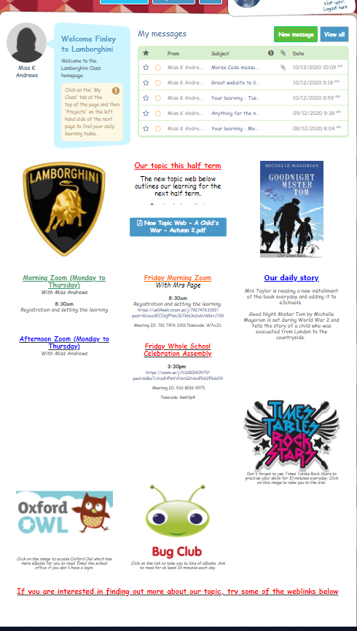
Setting up the work for the week:
TIP 1 – archive any previous projects to give you a clear class page at the end of each week.
To save parents/children searching where to find the work, create a project dated for the day. All of your work should be accessed here and children should be able to submit work here.

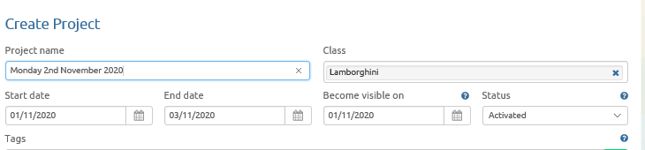

Create an item
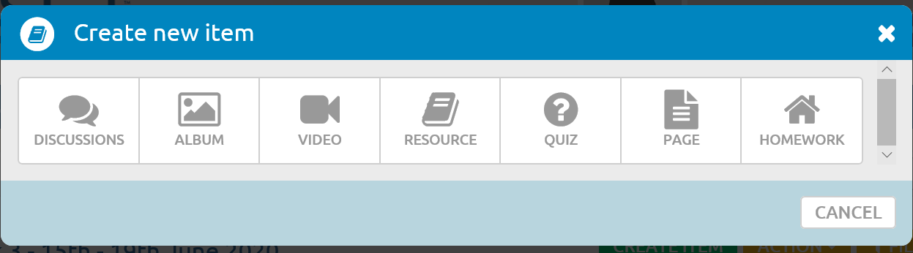

You can create videos to explain the Maths, English and Topic tasks. Keep the videos short and lower the quality to enable them to be uploaded easily to the page. It is important that we include these videos for parents/children who cannot, for whatever reason, attend the zoom. It should also mean your morning zoom can be quicker as the tasks are explained in the video.

For the White Rose Maths use ‘Resource’ to add the worksheets, answers and a link to the webpage with the videos. 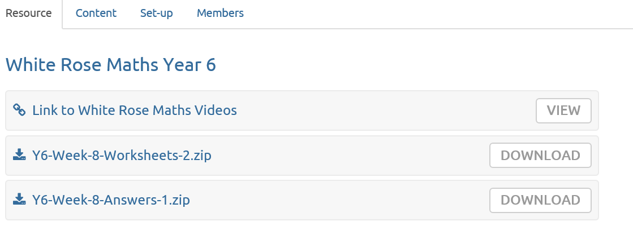
Use the resource button to download any PowerPoints, additional planning or resources etc. Make sure that each resource is clearly labelled. Remember you do not need to publish all resources to all children. You can differentiate the work that you set to children by choosing who you publish it to.
Here is an example of what it may look like:
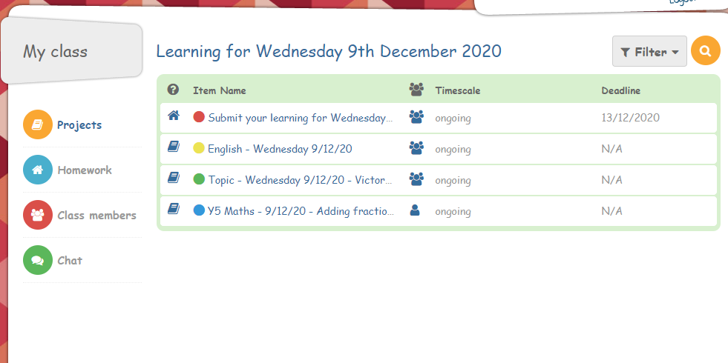

Finally, create a homework link (STILL IN THE PROJECTS SECTION NOT IN THE HOMEWORK SECTION) that should allow parents to upload completed work. Just remind parents to save as a draft until they have uploaded all of the work for the day.
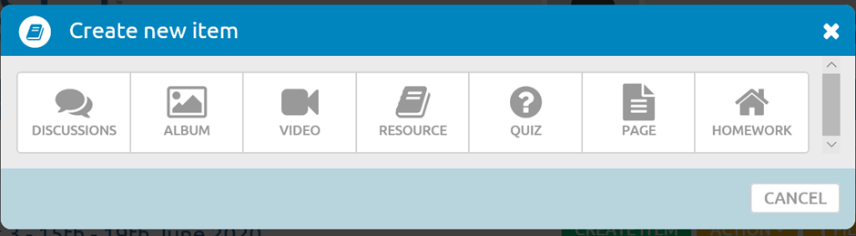
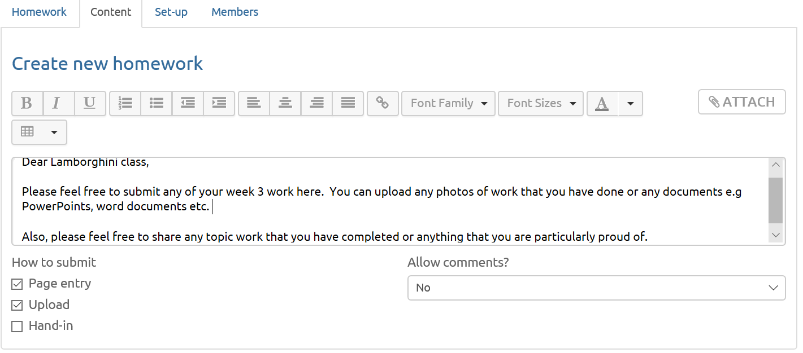
This is what it looks like on the child screen. It allows them to upload numerous documents, pictures and even short videos. They can also write directly into the page if you check the page entry box.
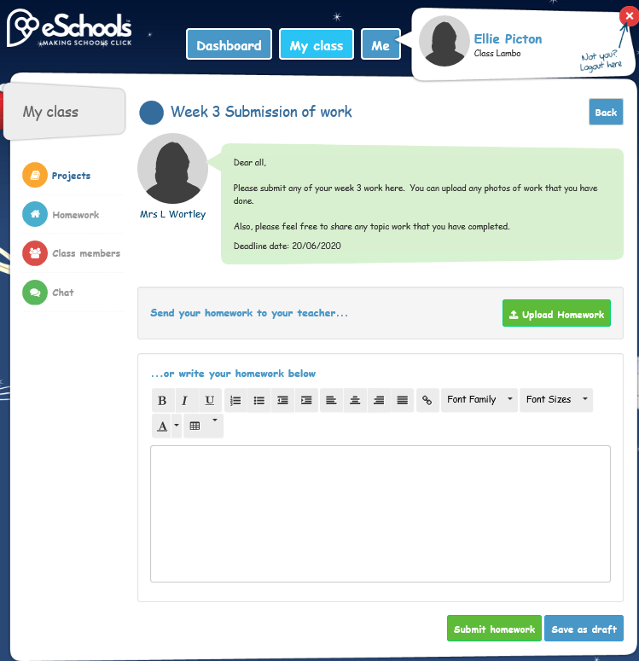
.
Try to stick to a similar format each day as this helps parents and children navigate.

Appendix C – eSchools Contents Guidance
Class Guidance
Homepage/Dashboard should contain:
- Your welcome message to the page and daily messages if necessary

- Your current photograph

- Your current topic web

- Your Zoom invitations for the week – written out – please see example below:

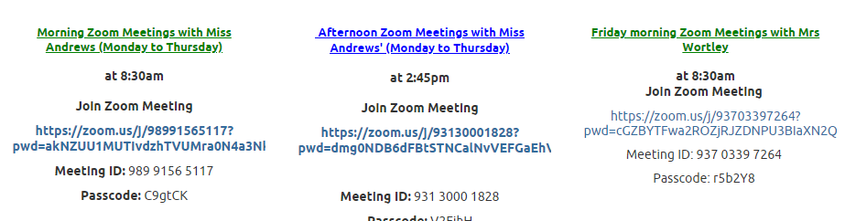

- House point totals

- Links to online learning – Bug Club, Oxford Owl, Spelling Frame, Education City, Espresso, TT Rockstars, MyMaths. Please include any relevant password information and any expectations and pictures – see example below:

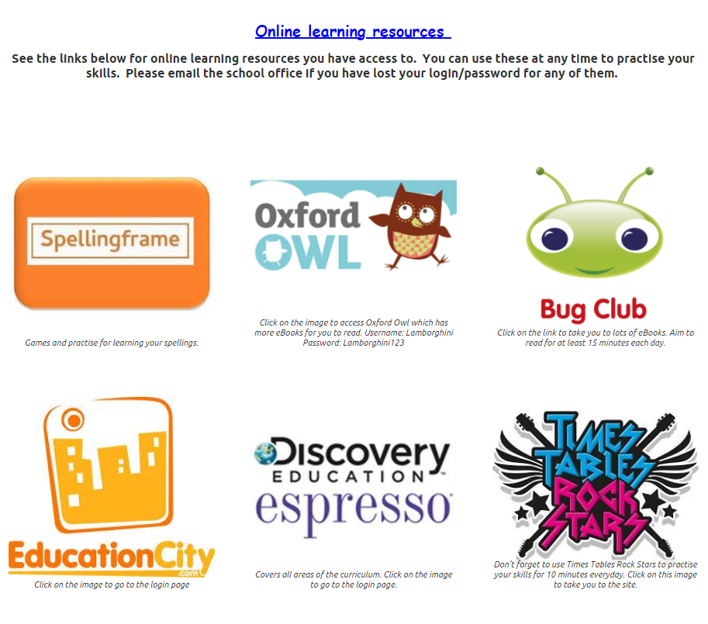

Projects Page should contain:
- The work for the day including your videos. These should be achieved on a weekly basis if they are not set up to display for their current week
- Italian work
- Art Challenge
- Pawprints
- Wellbeing Challenge
- Physical Challenge
- Daily Storytime Reading

