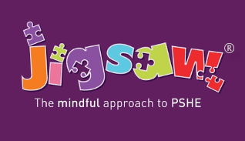

British Forces School Naples
PSHE (Personal, Social, Health Education) and Relationships and Health Education (including Sex Education )Policy

June 2021

Date for review: June 2022

Policy Contents:
Page: | Content:
2 | - Contents
3 | - Context  - PSHE  - Statutory Relationship and Health Education
4 | - Existing Guidance
5 | - What do we teach and when?
6 | - Relationship Education – what does guidance expect children to know?  - Health Education – what does guidance expect children to know?  - Sex Education – what does guidance recommend?
7 | - Parents’ right to request their child be excused from Sex Education
8-10 | - Content of sex education in Year groups  - Monitoring and review
11 | - Equality
12-13 | - ANNEX A - Relationships Education in Primary schools – DfE Guidance 2019
14-16 | - ANNEX B - Physical health and mental well-being education in Primary schools – DfE Guidance
17-19 | - ANNEX C – What format does a Jigsaw lesson follow?

Context
All schools must provide a curriculum that is broadly based, balanced and meets the needs of all pupils. Under section 78 of the Education Act 2002 and the Academies Act 2010, a PSHE curriculum:
- Promotes the spiritual, moral, cultural, mental and physical development of pupils at the school and of society, and
- Prepares pupils at the school for the opportunities, responsibilities and experiences of later life.

PSHE
At BFS Naples, we teach Personal, Social, Health Education as a whole-school approach to underpin children’s development as people and because we believe that this also supports their learning capacity.

The Jigsaw Programme offers us a comprehensive, carefully thought-through Scheme of Work which brings consistency and progression to our children’s learning in this vital curriculum area.
The overview of the programme can be seen on the school website.

This also supports the “Personal Development”and “Behaviour and Attitude” aspects required under the Ofsted Inspection Framework, as well as significantly contributing to the school’s Safeguarding and Equality Duties, the Government’s British Values aganda and the SMSC (Spiritual, Moral, Social, Cultural) development opportunities provided for our children.

Statutory Relationships and Health Education
“The Relationships Education, Relationships and Sex Education and Health Education (England) Regulations 2019, made under sections 34 and 35 of the Children and Social Work Act 2017, make Relationships Education compulsory for all pupils receiving primary education…They also make Health Education compulsory in all schools except independent schools. Personal, Social, Health and Economic Education(PSHE) continues to be compulsory in independent schools.”
DfE Guidance p.8

“Today’s children and young people are growing up in an increasingly complex world and living their lives seamlessly on and offline. This presents many positive and exciting opportunities, but also challenges and risks. In this environment, children and young people need to know how to be safe and healthy, and how to manage their academic, personal and social lives in a positive way.”

“This is why we have made Relationships Education compulsory in all primary schools in England…as well as making Health Education compulsory in all state-funded schools.”

“In primary schools, we want the subjects to put in place the key building blocks of healthy, respectful relationships, focusing on family and friendships, in all contexts, including online. This will sit alongside the essential understanding of how to be healthy.”

“These subjects represent a huge opportunity to help our children and young people develop. The knowledge and attributes gained will support their own, and others’ wellbeing and attainment and help young people to become successful and happy adults who make a meaningful contribution to society.”
Secretary of State Foreword DfE Guidance 2019 p.4-5

“Schools are free to determine how to deliver the content set out in the DfE guidance 2019 in the context of a broad and balanced curriculum. Effective teaching in these subjects will ensure that core knowledge is broken down into units of manageable size and communicated clearly to pupils, in a carefully sequenced way, within a planned programme of lessons.”
DfE Guidance p.8

“All schools must have in place a written policy for Relationships Education and RSE.”
DfE Guidance p.11

Here, at BFS Naples we value PSHE as one way to support children’s development as human beings, to enable them to understand and respect who they are, to empower them with a voice and to equip them for life and learning.

We include the statutory Relationships and Health Education within our whole-school PSHE Programme.

To ensure progression and a spiral curriculum, we use Jigsaw, the mindful approach to PSHE, as our chosen teaching and learning programme and tailor it to your children’s needs. The mapping document: Jigsaw 3-11 and statutory Relationships and Health Education, shows exactly how Jigsaw and therefore our school, meets the statutory Relationships and Health Education requirements.

This programme’s complimentary update policy ensures we are always using the most up to date teaching materials and that our teachers are well-supported.

Exisiting Guidance

Our PSHE policy is informed by existing DfE guidance:
- Keeping Children Safe in Education (statutory guidance)
- Respectful School Communities: Self Review and Signposting Tool (a tool to support a whole school approach that promotes respect and discipline)
- Behaviour and Discipline in Schools (advice for schools, including advice for appropriate behaviour between pupils)
- Equality Act 2010 and schools
- SEND code of practice: 0 to 25 years (statutory guidance)
- Alternative Provision (statutory guidance)
- Mental Health and Behaviour in Schools (advice for schools)
- Preventing and Tackling Bullying (advice for schools, including advice on cyberbullying)
- Sexual violence and sexual harassment between children in schools (advice for schools)
- The Equality and Human Rights Commission Advice and Guidance (provides advice on avoiding discrimination in a variety of educational contexts)
- Promoting Fundamental British Values as part of SMSC in schools (guidance for maintained schools on promoting basic important British values as part of pupils’ spiritual, moral, social and cultural (SMSC)
- SMSC requirements for independent schools (guidance for independent schools on how they should support pupils' spiritual, moral, social and cultural development).
The Jigsaw Programme is aligned to the PSHE Association Programmes of Study for PSHE.

What do we teach when and who teaches it?

Whole-school approach
Jigsaw covers all areas of PSHE for the primary phase including statutory Relationships and Health Education. The table below gives the learning theme of each of the six Puzzles (units) and these are taught across the school; the learning deepens and broadens every year.

Term | Puzzle (Unit) | Content
Autumn 1: | Being Me in My World | Includes understanding my own identity and how I fit well in the class, school and global community. Jigsaw Charter established.
Autumn 2: | Celebrating Difference | Includes anti-bullying (cyber and homophobic bullying included) and understanding
Spring 1: | Dreams and Goals | Includes goal-setting, aspirations, who do I want to become and what would I like to do for work and to contribute to society
Spring 2: | Healthy Me | Includes drugs and alcohol education, self-esteem and confidence as well as healthy lifestyle choices, sleep, nutrition, rest and exercise
Summer 1: | Relationships | Includes understanding friendship, family and other relationships, conflict resolution and communication skills, bereavement and loss
Summer 2: | Changing Me | Includes Relationships and Sex Education in the context of coping positively with change

At BFS Naples we teach PSHE weekly in order to teach the PSHE knowledge and skills in a developmental and age-appropriate way.
These explicit lessons are reinforced and enhanced in many ways:
Assemblies and collective worship, praise and reward system, Learning Charter, through relationships child to child, adult to child and adult to adult across the school. We aim to ‘live’ what is learnt and apply it to everyday situations in the school community.
Class teachers deliver the weekly lessons to their own classes.

Relationships Education – what does guidance expect children to know?
What does the DfE statutory guidance on Relationships Education expect children to know by the time they leave primary school?
Relationships Education in primary schools will cover ‘Families and people who care for me’, ‘Caring friendships’, ‘Respectful relationships’, ‘Online relationships’, and ‘Being safe’.
The expected outcomes for each of these elements can be found further on in this policy. The way the Jigsaw Programme covers these is explained in the mapping document: Jigsaw 3-11 and Statutory Relationships and Health Education.
It is important to explain that whilst the Relationships Puzzle (unit) in Jigsaw covers most of the statutory Relationships Education, some of the outcomes are also taught elsewhere in Jigsaw e.g. the Celebrating Difference Puzzle helps children appreciate that there are many types of family composition and that each is important to the children involved. This holistic approach ensures the learning is reinforced through the year and across the curriculum.
Health Education – what does guidance expect children to know?
What does the DfE statutory guidance on Health Education expect children to know by the time they leave primary school?
Health Education in primary schools will cover ‘Mental wellbeing’, ‘Internet safety and harms’, Physical health and fitness’, Healthy eating’, ‘Drugs, alcohol and tobacco’, ‘Health and prevention’, ‘Basic First Aid’, ‘Changing adolescent body’.
The expected outcomes for each of these elements can be found further on in this policy. The way the Jigsaw Programme covers these is explained in the mapping document: Jigsaw 3-11 and Statutory Relationships and Health Education.
It is important to explain that whilst the Healthy Me Puzzle (unit) in Jigsaw covers most of the statutory Health Education, some of the outcomes are taught elsewhere in Jigsaw e.g.emotional and mental health is nurtured every lesson through the Calm me time, social skills are grown every lesson through the Connect us activity and respect is enhanced through the use of the Jigsaw Charter.
Also, teaching children about puberty is now a statutory requirement which sits within the Health Education part of the DfE guidance within the ‘Changing adolescent body’ strand, and in Jigsaw this is taught as part of the Changing Me Puzzle (unit).
Again, the mapping document transparantly shows how the Jigsaw whole-school approach spirals the learning and meets all statutory requirements and more.
Sex Education – what does guidance recommend?
The DfE Guidance 2019 (p.23) recommends that all primary schools ‘have a sex education programme tailored to the age and the physical and emotional maturity of the pupils.
However, ‘Sex Education is not compulsory in primary schools’. (p. 23)
Schools are to determine the content of sex education at primary school. Sex education ‘should ensure that both boys and girls are prepared for the changes that adolescence brings and – drawing on knowledge of the human life cycle set out in the national curriculum for science - how a baby is conceived and born’.
At BFS Naples, we believe children should understand the facts about human reproduction before they leave primary school so they can lead confident, healthy, independent lives and to become informed, active and responsible citizens
We define Sex Education as ‘ a lifelong learning process of acquiring information, developing skills and forming positive beliefs and attitudes about sex, sexuality, relationships and feelings’ (Sex Education Forum, 1999).
We intend to teach this both through Science and PSHE. When reproduction is taught In Science (Year 5) it is compulsory for children in which case parents can’t withdraw their child/ren from this area of the curriculum. When Sex Education is taught as part of PSHE, parents have the right to withdraw.
Parents’ right to request their child be excused from Sex Education
“Parents have the right to request that their child be withdrawn from some or all of sex education delivered as part of statutory Relationships and Sex Education” DfE Guidance p.17
At BFS Naples, puberty is taught as a statutory requirement of Health Education and covered by our Jigsaw PSHE Programme in the ‘Changing Me’ Puzzle (unit). We conclude that sex education refers to Human Reproduction, and therefore inform parents of their right to request their child be withdrawn from the PSHE lessons that explicitly teach this. The content of which is outlined below: and invite you to contact the class teacher in the first instance.
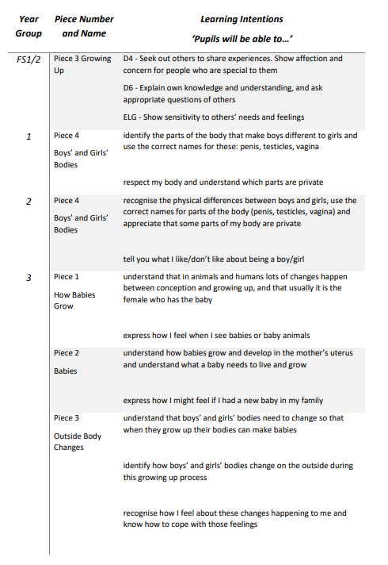

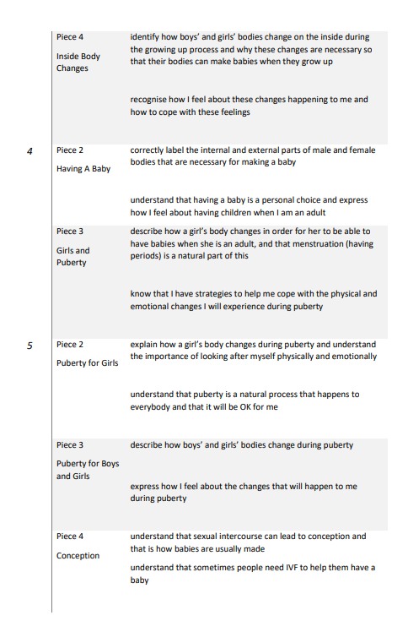
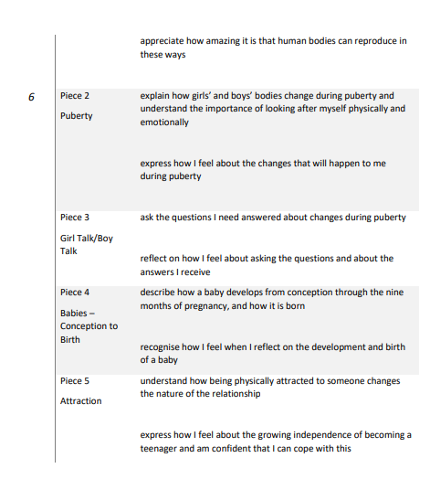
The school will inform parents of the right to withdraw by letter/email. The teaching of the ‘Changing Me’ unit we will also be acknowledged on Topic Overviews which are handed out at the beginning of each term. The ‘Changing Me’ unit with usually be taught in Term 6. Should parents wish to withdraw their children they should arrange a meeting with the headteacher to discuss this.
Monitoring and Review
The SGC and SLT monitors this policy on an annual basis. We give serious consideration to any comments from parents about the PSHE (RSHE) programme, and makes a record of all such comments.

Equality
This policy will inform the school’s Equalities Plan.
The DfE Guidance 2019 (p. 15) states, “Schools should ensure that the needs of all pupils are appropriately met, and that all pupils understand the importance of equality and respect. Schools must ensure they comply with the relevant provisions of the Equality Act 2010 under which sexual orientation and gender reassignment are amongst the protected characteristics…

At the point at which schools consider it appropriate to teach their pupils about LGBT (Lesbian, Gay, Bisexual, Transgender), they should ensure this content is fully integrated into their programmes of study for this area of the curriculum rather than delivered as a stand-alone unit or lesson. Schools are free to determine how they do this, and we expect all pupils to have been taught LGBT content at a timely point as part of this area of the curriculum”.
At BFS Naples we promote respect for all and value every individual child. We also respect the right of our children, their families and our staff, to hold beliefs, religious or otherwise, and understand that sometimes these may be in tension with our approach to some aspects of Relationships, Health and Sex Education.

For further explanation as to how we approach LGBT relationships in the PSHE (RSHE) Programme please see:
‘Including and valuing all children. What does Jigsaw teach about LGBTQ relationships?’

Policy Review
This policy is reviewed annually.
Date of next review: June 2022

Jigsaw PSHE documents needed to explain this policy:
- Jigsaw 3-11 and statutory Relationships and Health Education (mapping document)
- Including and valuing all children. What does Jigsaw teach about LGBTQ relationships?

ANNEX A - Relationships Education in Primary schools – DfE Guidance 2019
The focus in primary school should be on teaching the fundamental building blocks and characteristics of positive relationships, with particular reference to friendships, family relationships, and relationships with other children and with adults.
The guidance states that, by the end of primary school:
 | Pupils should know… | How Jigsaw provides the solution
Families and people who care for me | - that families are important for children growing up because they can give love, security and stability.  - the characteristics of healthy family life, commitment to each other, including in times of difficulty, protection and care for children and other family members, the importance of spending time together and sharing each other’s lives.  - that others’ families, either in school or in the wider world, sometimes look different from their family, but that they should respect those differences and know that other children’s families are also characterised by love and care.  - that stable, caring relationships, which may be of different types, are at the heart of happy families, and are important for children’s security as they grow up.  - that marriage represents a formal and legally recognised commitment of two people to each other which is intended to be lifelong (Marriage in England and Wales is available to both opposite sex and same sex couples. The Marriage (Same Sex Couples) Act 2013 extended marriage to same sex couples in England and Wales. The ceremony through which a couple get married may be civil or religious).  - how to recognise if family relationships are making them feel unhappy or unsafe, and how to seek help or advice from others if needed.  - about different types of bullying (including cyberbullying), the impact of bullying, responsibilities of bystanders (primarily reporting bullying to an adult) and how to get help.  - what a stereotype is, and how stereotypes can be unfair, negative or destructive.  - the importance of permission-seeking and giving in relationships with friends, peers and adults. | All of these aspects are covered in lessons within the Puzzles  - Relationships  - Changing Me  - Celebrating Difference  - Being Me in My World
Online relationships | - that people sometimes behave differently online, including by pretending to be someone they are not.  - that the same principles apply to online relationships as to face-to-face relationships, including the importance of respect for others online including when we are anonymous.  - the rules and principles for keeping safe online, how to recognise risks, harmful content and contact, and how to report them.  - how to critically consider their online friendships and sources of information including awareness of the risks associated with people they have never met.  - how information and data is shared and used online. | All of these aspects are covered in lessons within the Puzzles  - Relationships  - Changing Me  - Celebrating Difference
Being safe | - what sorts of boundaries are appropriate in friendships with peers and others (including in a digital context).  - about the concept of privacy and the implications of it for both children and adults; including that it is not always right to keep secrets if they relate to being safe.  - that each person’s body belongs to them, and the differences between appropriate and inappropriate or unsafe physical, and other, contact.  - how to respond safely and appropriately to adults they may encounter (in all contexts, including online) whom they do not know.  - how to recognise and report feelings of being unsafe or feeling bad about any adult.  - how to ask for advice or help for themselves or others, and to keep trying until they are heard,  - how to report concerns or abuse, and the vocabulary and confidence needed to do so.  - where to get advice e.g. family, school and/or other sources. | All of these aspects are covered in lessons within the Puzzles  - Relationships  - Changing Me  - Celebrating Difference

ANNEX B - Physical health and mental well-being education in Primary schools – DfE Guidance
The focus in primary school should be on teaching the characteristics of good physical health and mental wellbeing. Teachers should be clear that mental well-being is a normal part of daily life, in the same way as physical health.
By the end of primary school:
 | Pupils should know | How Jigsaw provides the solution
Mental wellbeing | - that mental wellbeing is a normal part of daily life, in the same way as physical health.  - that there is a normal range of emotions (e.g. happiness, sadness, anger, fear, surprise, nervousness) and scale of emotions that all humans experience in relation to different experiences and situations.  - how to recognise and talk about their emotions, including having a varied vocabulary of words to use when talking about their own and others’ feelings.  - how to judge whether what they are feeling and how they are behaving is appropriate and proportionate.  - the benefits of physical exercise, time outdoors, community participation, voluntary and service-based activity on mental well-being and happiness.  - simple self-care techniques, including the importance of rest, time spent with friends and family and the benefits of hobbies and interests.  - isolation and loneliness can affect children and that it is very important for children to discuss their feelings with an adult and seek support.  - that bullying (including cyberbullying) has a negative and often lasting impact on mental well-being.  - where and how to seek support (including recognising the triggers for seeking support), including whom in school they should speak to if they are worried about their own or someone else’s mental well-being or ability to control their emotions (including issues arising online).  - it is common for people to experience mental ill health. For many people who do, the problems can be resolved if the right support is made available, especially if accessed early enough. | All of these aspects are covered in lessons within the Puzzles  - Healthy Me  - Relationships  - Changing Me  - Celebrating Difference
Internet safety and harms | - that for most people the internet is an integral part of life and has many benefits.  - about the benefits of rationing time spent online, the risks of excessive time spent on electronic devices and the impact of positive and negative content online on their own and others’ mental and physical wellbeing.  - how to consider the effect of their online actions on others and knowhow to recognise and display respectful behaviour online and the importance of keeping personal information private.  - why social media, some computer games and online gaming, for example, are age restricted.  - that the internet can also be a negative place where online abuse, trolling, bullying and harassment can take place, which can have a negative impact on mental health.  - how to be a discerning consumer of information online including understanding that information, including that from search engines, is ranked, selected and targeted.  - where and how to report concerns and get support with issues online. | All of these aspects are covered in lessons within the Puzzles  - Relationships  - Healthy Me
Physical health and fitness | - the characteristics and mental and physical benefits of an active lifestyle.  - the importance of building regular exercise into daily and weekly routines and how to achieve this; for example, walking or cycling to school, a daily active mile or other forms of regular, vigorous exercise.  - the risks associated with an inactive lifestyle (including obesity).  - how and when to seek support including which adults to speak to in school if they are worried about their health. | All of these aspects are covered in lessons within the Puzzles  - Healthy Me
Healthy eating | - what constitutes a healthy diet (including understanding calories and other nutritional content).  - the principles of planning and preparing a range of healthy meals.  - the characteristics of a poor diet and risks associated with unhealthy eating (including, for example, obesity and tooth decay) and other behaviours (e.g. the impact of alcohol on diet or health). | All of these aspects are covered in lessons within the Puzzles  - Healthy Me
Drugs, alcohol and tobacco | - how to recognise early signs of physical illness, such as weight loss, or unexplained changes to the body.  - about safe and unsafe exposure to the sun, and how to reduce the risk of sun damage, including skin cancer.  - the importance of sufficient good quality sleep for good health and that a lack of sleep can affect weight, mood and ability to learn.  - about dental health and the benefits of good oral hygiene and dental flossing, including regular check-ups at the dentist.  - about personal hygiene and germs including bacteria, viruses, how they are spread and treated, and the importance of handwashing.  - the facts and science relating to immunisation and vaccination | All of these aspects are covered in lessons within the Puzzles  - Healthy Me
Basic first aid | - how to make a clear and efficient call to emergency services if necessary.  - concepts of basic first-aid, for example dealing with common injuries, including head injuries. | All of these aspects are covered in lessons within the Puzzles  - Healthy Me
Changing adolescent body | - key facts about puberty and the changing adolescent body, particularly from age 9 through to age 11, including physical and emotional changes.  - about menstrual wellbeing including the key facts about the menstrual cycle. | All of these aspects are covered in lessons within the Puzzles  - Changing Me  - Healthy Me

ANNEX C – What format does a Jigsaw lesson follow?
The Learning Environment
Establishing a safe, open and positive learning environment based on trusting relationships between all members of the class, adults and children alike, is vital. To enable this, it is important that ‘ground rules’ are agreed and owned at the beginning of the year and are reinforced in every Piece – by using The Jigsaw Charter. (Ideally, teachers and children will devise their own Jigsaw Charter at the beginning of the year so that they have ownership of it.) It needs to include the aspects below:
The Jigsaw Charter
• We take turns to speak
• We use kind and positive words
• We listen to each other
• We have the right to pass
• We only use names when giving compliments or when being positive
• We respect each other’s privacy (confidentiality)
The Jigsaw Circle
Most Puzzles include the use of The Jigsaw Circle in some Pieces. The Jigsaw Circle is a tried and tested teaching approach, popularised most successfully in recent years by Jenny Mosley. It brings children and adults together to feel equal and valued so that they can share ideas, thoughts and feelings. Sitting in a circle either all on chairs or all on the floor means adults and children are sharing the experience and learning together. If children are not used to the circle approach, it may be necessary to rehearse this with them in small groups before bringing the whole class together. The circle approach is used regularly in Jigsaw. It is important that children understand the circle approach rules so that they feel safe and valued and enjoy these experiences. A structured approach, building up to a full circle time will be introduced gradually. Using the Jigsaw Friend (talking object) is a useful distancing technique and helps children work with potentially sensitive issues without asking them directly. The Jigsaw Circle Charter is central to the creation of a safe and trusted circle environment.

Jigsaw Songs
The specially-composed original songs are introduced in the assemblies and used in the Pieces to reinforce the learning messages of each Puzzle. Each song has 4 tracks i) choir with backing ii) instrumental iii) choir and backing: different arrangement iv) instrumental
The Structure of the Pieces (lessons) in Jigsaw
There are six main elements to each Jigsaw lesson. The sessions all start with the Jigsaw charter which overarches each session.
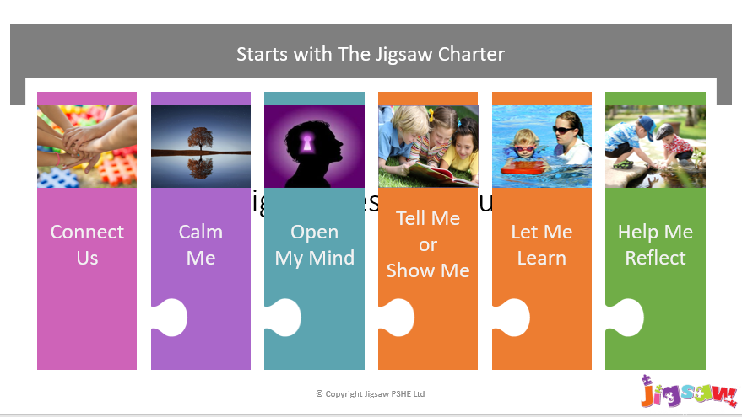
Connect us - Explain the circle charter to children and reinforce it throughout every circle time. The Connect us section is designed to maximise social skills, to engender positive relationships and enhance collaborative learning. There are a range of games to choose from that are there to systematically build social skills and to start the lesson in an inclusive and fun way.
Calm me - This section of the Piece aims to still the children’s minds, relaxing them and quietening their emotions to a place of optimum learning capacity. This will also engender a peaceful atmosphere within the classroom. Using the Jigsaw Chime and the Calm Me exercises is an easy introduction to techniques which help children relax their bodies and calm their minds, reaching an optimum state for learning. The aim is to bring children’s awareness/attention to the present moment and in so doing let go of other thoughts that might be scurrying around the mind which distract from focusing on the learning of this lesson.
Open my mind - This is a short activity designed to help the children’s minds focus in on the essence of the learning coming up in the lesson. We want children’s minds to deem the forthcoming learning ‘significant’ so ”Open my mind’ helps make the mind receptive to the specific learning in this lesson. It might be as simple as finishing a stem sentence of looking at and discussing a picture on the screen.
Tell me or show me - This section of the Piece (lesson) is used to introduce new information, concepts and skills, using a range of teaching approaches and activities.
Let me learn - this is the learning activity. The children now do the activity/game/drawing/role-play etc to internalize the learning, to make it their own and to accommodate it into their own frame of reference.
Help me reflect -Throughout Jigsaw, children are encouraged to reflect on their learning experiences and their progress. By reflecting, children can process and evaluate what they have learnt, which enables them to consolidate and apply their learning. Closure - Each Piece, particularly when run as a circle approach, needs safe closure. This will always include the teacher praising the children for their effort, positive attitude and achievement, as well as giving one or two sentences to summarise the key learning points for the children.

Puzzle Outcome/End Product
In each series of 6 Pieces (lessons), learning builds and develops. In each Puzzle, this learning culminates in an end product/outcome, for example, a display, a fashion show, a presentation, a video/film, a concert, or an exhibition. This way, each Piece of learning adds to the process of creating the end product, giving the learning an additional purpose, rather than being an end in itself. Children will know what they are working towards early in the Puzzle, adding motivation to their work.
The Jigsaw Journal
Children will store all evidence of their learning in their individual yellow folders. Each lesson has a My Jigsaw Learning sheet in KS1. Children colour in or circle the Jigsaw Friend relevant to how they feel relating to teach Learning Intention. The KS2 My Jigsaw Journey pages have x3 lessons worth of Learning Intentions on them which children can use to help them to complete their reflections.
Supporting teacher assessment
A simple one page assessment guide is included with every Puzzle (unit) to support teacher judgements and moderation of children’s learning. Specific assessment exemplification for every assessment activity is also included within the relevant lesson resources.

