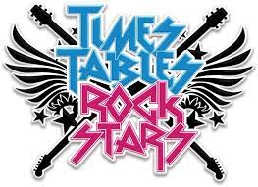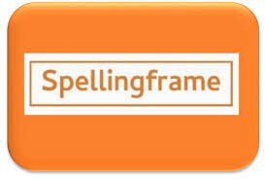
Parent Guide to Learning Platforms and Apps

Contents
Contents and Introduction | 1
e-Schools (all children) | 2
Spelling Frame (Years 1-6) | 3
Times Table Rockstars (Years 1-6) | 4
My Maths (Years 1-6) | 5
Education City (all children) | 6
Bug Club (all children) | 7 -8
Espresso (all children) | 9
Target Tracker Link (FS1/2 only) | 10

At British Forces School Naples, we use a number of different platforms and sites to support your child in their online learning both in school and at home. These can all be accessed through a phone, tablet or computer.
This booklet aims to guide you through accessing the different options available to you. Some platforms are used to set home learning whilst others are for your child to access freely as they wish. You will find a list of passwords accompanying this booklet to enable you and your child to log on to the different platforms and sites.
If you have any difficulties with accessing the platforms or with your passwords, please contact the school office:
Naples.ictadmin@modschools.gov.uk
If you or your child would like additional support in how to use any of the platforms, please contact your class teacher directly.

e-Schools
To get the full experience, we recommend that you access e-Schools through a web browser rather than the app following this link:
https://bfsnaples.eschools.co.uk/
At British Forces School Naples, we use e-Schools for a variety of purposes:
- Set weekly home learning (Years 1-6)
- Set class learning during periods of remote learning
- Publish topic webs, timetables and class information
- Display links to other online learning resources

If you are having any difficulties navigating around the pages, follow the link below. You will find a range of useful videos that will help with issues such logging in, accessing projects and home learning, writing messages and adding profile pictures.
https://academy.eschools.co.uk/users/students/primary-student/

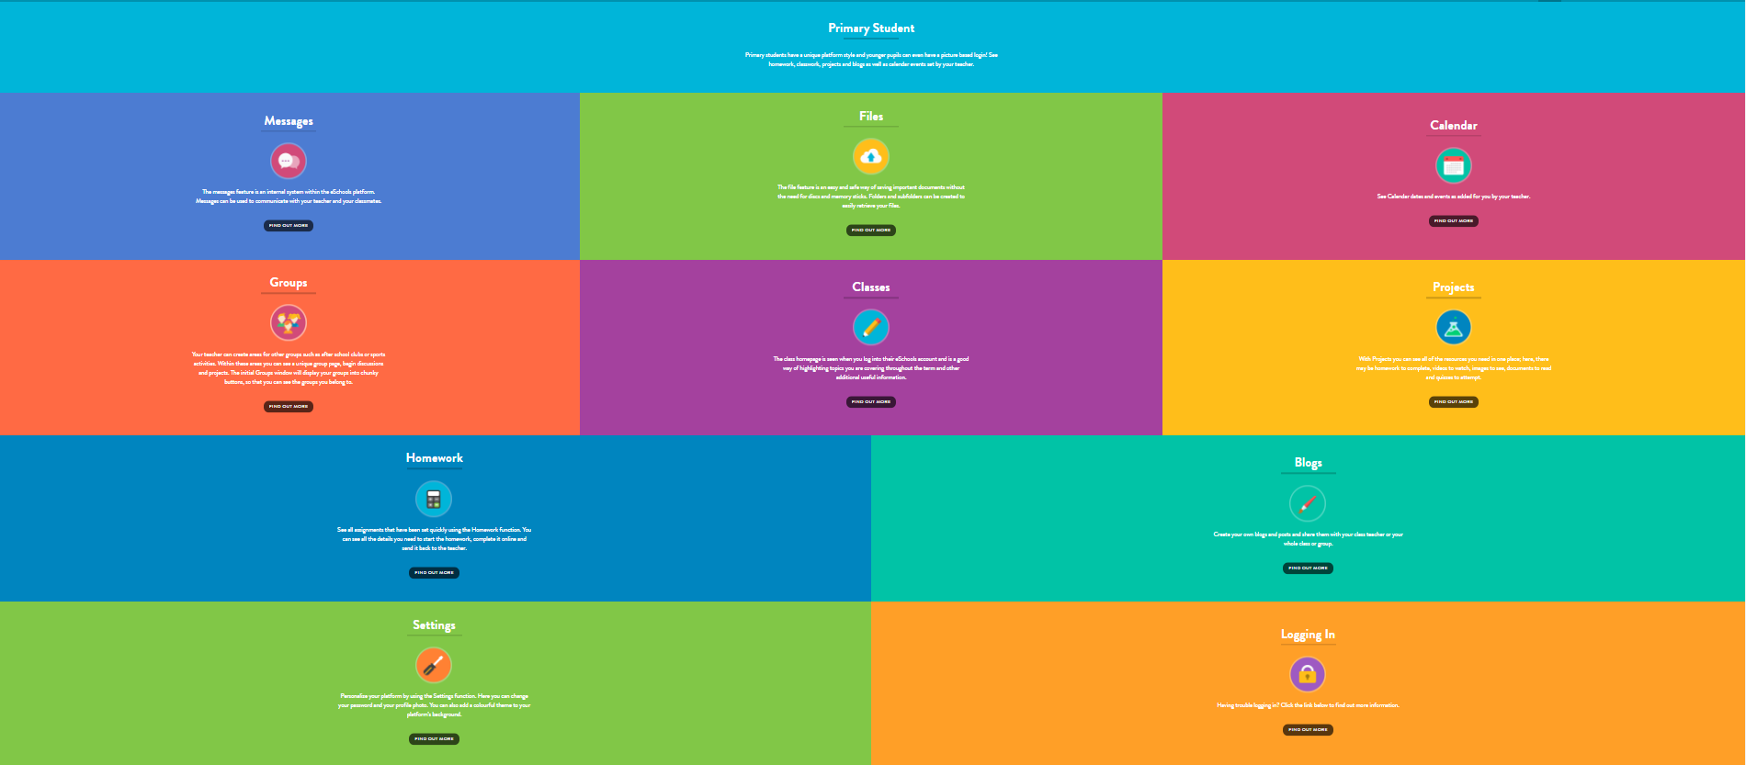

Spelling Frame
Spelling Frame is accessed through a web browser on the link below:
https://spellingframe.co.uk/
The Spelling Frame website that links directly to the spelling rules and words taken from the national curriculum; it is a brilliant tool to help support your child's spelling at home. It can be accessed either on a computer, tablet or phone and is very user-friendly. This platform is used for our pupils in Year 1 and above.
Simply begin by logging in at the top right-hand corner of the page.
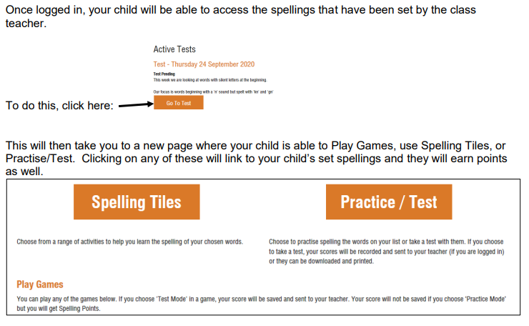

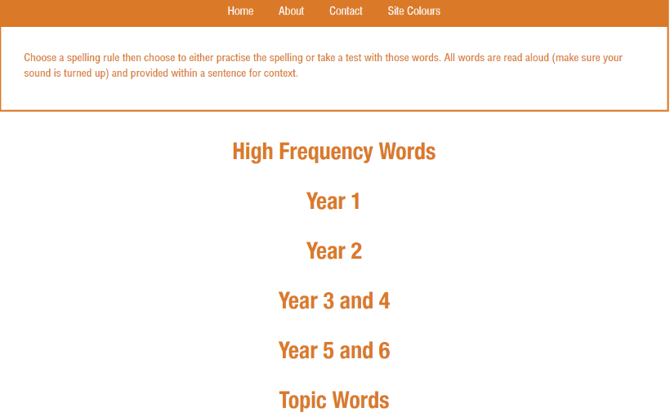
If your child does not have any specific words set by their class teacher they can click on the homepage and then they will see this list shown on the right. Children can then choose the spelling rule that they wish to practise: they will then be able to access different games and resources to help learn those specific words for that specific rule.

Times Table Rockstars

We are all aiming to become Times Tables Rockstars and know our multiplication facts in lightning speed! Times Tables Rockstars is a website that lets children practice their times table in a fun, engaging and rewarding way. It lets them create and build a cool avatar, join a battle of bands against other classes and compete in times tables festivals against children around the world!
https://play.ttrockstars.com/auth/school/student
Once you are on the website you will be asked to login. Start typing in "British Forces School Naples" and click on the school's name when it appears. Then put in your username and password to login
How the site works
When you login in to the website, you will be greeted by a choice of single or multi-layer. Either option will take you to different playing modes. The four main game modes we suggest are: Garage, Studio, Festival and Arena. Below is an explanation of each.
Garage
We recommend that children play Garage by default as it is designed help them get faster. In this mode class teachers will set which times tables children can focus on.
The website will also work out which questions children struggle with so it will then ask those more often.
Additionally, children playing in the Garage will get 10 coins per correct answer rather than the 1 coin per answer in the other modes. This means more money to spend on their avatar!
Studio
Just like a rock star recording their next big album, children should play in the studio when they are ready to give their best performance. The questions can be anything up to 12x12.
When you play in the studio the website will work out your times tables speed, or how long it takes you to answer each question. Once you have played 10 games in studio the website will work out your average and you will be able to see whether you are a Rock Star, Rock Legend, or even a Rock God!
Arena and Festival
The Arena and Festival are the multiplayer versions of the game. If children want to compete against each other they can go into the arena and do battle with other children!
In the Arena, children can compete against children in their class who are playing at the same time,
In Festival however, the games are open to anyone, anywhere!
New games start every 15 seconds. Just click on the one you want to join. It will highlight in green. Wait for the game to start (timer is on the left) and crush your opponent!
Top Tips
Here is some expert advice to get yourself top of the leader board:
- If you're on a computer, use the number pad on the right of the keyboard.
- Keep your right hand on the number pad and have your left finger on the backspace to correct mistakes instantly.
- Try your hardest to figure out the answer to each question. The process of working it out will help you remember it for next time.
MyMaths

MyMaths provides complete curriculum coverage from Key Stage 1 to Key Stage 2. Our subscription to MyMaths means that your child can access the online content at home, which allows them to access a wide range of games, activities, homework tasks and investigations that will help develop confidence and fluency in maths.
In Years 1-6, children may be asked to complete their homework on-line, using the MyMaths programme. This provides children and teachers with instant feedback.
Please visit: https://www.mymaths.co.uk/
If you would like help with using MyMaths, please visit the site below to watch a brief video demo for parents and carers of how to navigate around the platform.
https://home.oxfordowl.co.uk/maths/primary-mymaths-guide-for-parents/
If your child has completed home learning on MyMaths, they should log back in regularly to the portal to see if their teacher has left a message or to check scores.
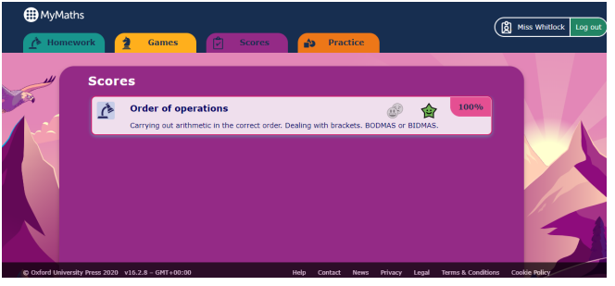
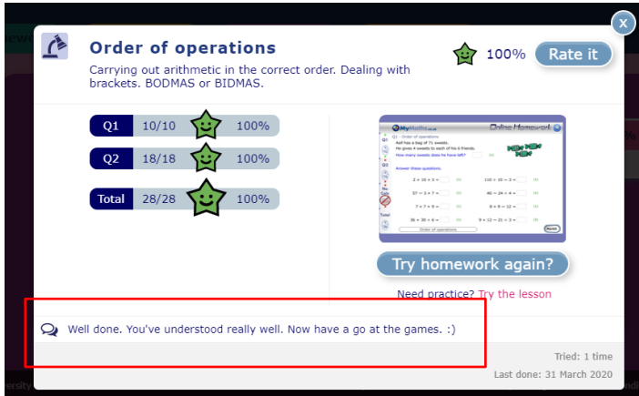
Click onto the SCORES tab for completed homework tasks. Click onto each task. A summary of the scores will appear. Children will have the chance to repeat the task to try and improve their score if they wish. They might even spot a message from their teacher. Can you see it inside the red box?

Education City
EducationCity specialises in primary teaching resources with curriculum-mapped content for students aged 3-12. Occasionally, children may have home learning or class learning set on this platform. Children can also access the content and activities freely anytime.
Follow the link below to access a webinar which will help you to navigate around Education City so that you can best support your child.
Understanding How to Use EducationCity - A Guide for Parents Webinar

https://www.youtube.com/watch?v=2QV2Pu7KCyQ

Espresso
All of our children have access to Espresso and Espresso Coding.
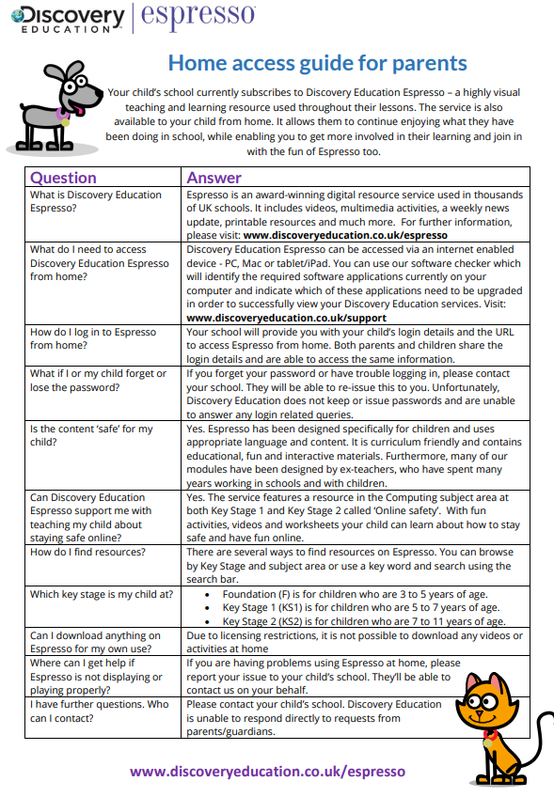
How to Access Target Tracker Link
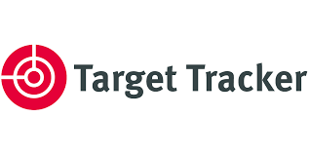
For parents of children in FS1 and FS2, in order to keep you involved in your child’s learning journey, we use an online system called Target Tracker Link. Target Tracker Link is a secure online system we use to share observations of your child that you can access easily online. These observations are part of our regular ongoing assessment and help record your child’s learning.
Please see below information to access Target Tracker link:
Use the following link to take you to Target Tracker Link website: www.targettrackerlink.com/school
Pick your school (school name): BFS Naples
Your username and password can be setup via the link sent to the e-mail address you provided us with. Once setup, enter your username and password to access your child’s Target Tracker.

