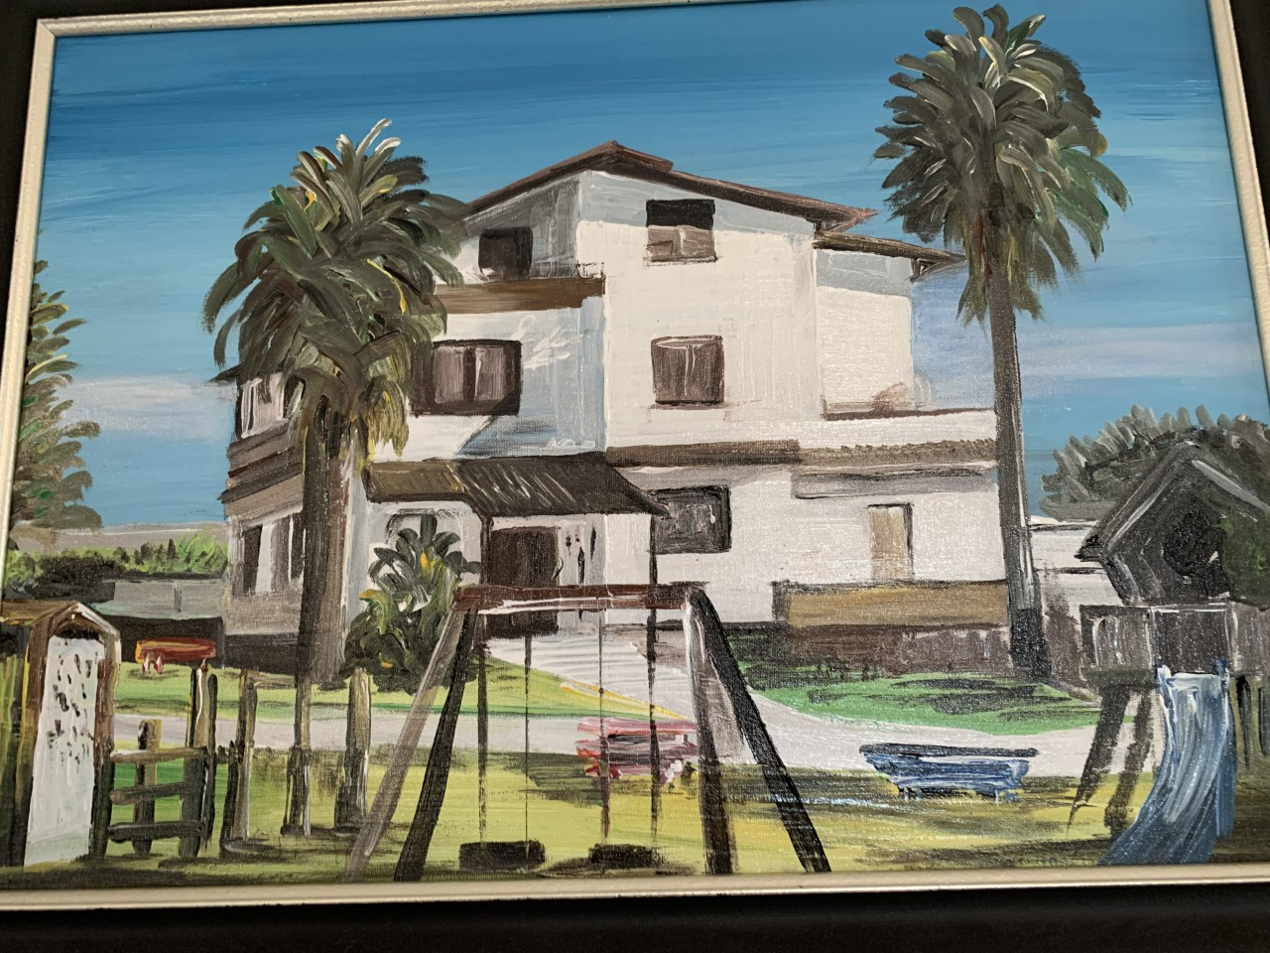

|  |
| --- |
|  |
| Information Booklet for Parents |
| |  |  |  | | --- | --- | --- | | Helen Botterill | Be the best that you can be in all that you do |  | |

**Contents**

|  |  |  |
| --- | --- | --- |
| Welcome Letter | | 2 |
| Ministry of Defence Schools | | 3 |
| Aims of British Forces School Naples | | 4 |
| School Organisation | | |
| Admission and Transfers | | 5 |
| Organisation and Staff | | 6 |
| Term Dates | | 7 |
| The School Day | | 8 |
| Transport | | 8 |
| Snack and Lunch | | 9 |
| School Uniform | | 10 |
| Medical and Safety | | 11-12 |
| Attendance | | 13 |
| Curriculum and Home Learning | | 14-17 |
| Behaviour | | 18-19 |
| SEND | | 20 |
| FoBFS and SGC | | 21 |
| Home and School Liaison | | 22 |
| Complaints Procedure | | 23 |
| Annexes | | |
| A | Request for Term Time pupil Leave – Exceptional Circumstances | 24 |
| B | Request for Term Time Leave - | 25 |
| C | Top Ten Tips for Reading | 26 |
| D | Learning Behaviours | 27 |
| E | Privacy Notice (How we use pupil information) | 28-32 |
| F | Checklist of forms to return to the office | 33 |

|  |  |  |
| --- | --- | --- |
|  | **C:\Users\wortleyl51\AppData\Local\Microsoft\Windows\INetCache\Content.MSO\51019FF3.tmp**  **BRITISH FORCES SCHOOL, NAPLES**  **AJFC HQ NAPLES, BFPO 8**  **Tel 1: (0039) 3475103211**  **Tel 2: (0039) 3490077229**  **Email: Naples.School@modschools.org**  **HEADTEACHER: Mrs R Robinson** |  |

**Be The Best That You Can Be In All That You Do**

 Dear Parents

I would like to welcome you to Naples and especially to our school.

We are very proud of our achievements and everyone at the school will work very hard to ensure your child is happy and makes good progress.  Italy is a beautiful country and Naples has much to offer, with many historical and geographical sites to visit.  Our Curriculum builds on these opportunities and provides the children with a wide and varied range of experiences.

We believe you play an essential role in your child's education.  There are numerous opportunities to support your child in school, from helping with home learning, volunteering for school visits, helping in school or sharing any special skills you may have.  We welcome parents as partners and believe your partnership with us is key to your child’s learning.  Our school is friendly and open and we welcome the opportunity to discuss our work, any concerns or questions.

This booklet outlines our work and will help to answer some of the questions you may have.

On behalf of all the staff, I wish you a successful and enjoyable stay in Naples.

Yours sincerely

**C:\Users\wortleyl51\AppData\Local\Microsoft\Windows\INetCache\Content.MSO\E1CF5179.tmp**

Mrs Rebecca Robinson

Headteacher

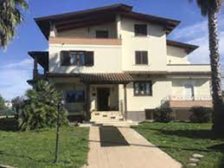Ministry of Defence (MOD) Schools is part of the MOD. MOD Schools provides schools and educational support for children of the UK armed forces; Ministry Of Defence personnel and MOD sponsored organisation stationed overseas. MOD Schools are intended, as far as possible, to provide the same pattern of education as that given in England.  The education will therefore mirror that provided in England under the Education Acts, although these have no legal validity overseas.  MOD Schools and Settings are part of the Defence Children Services (DCS).For further information visit:

<https://www.gov.uk/government/groups/defence-children-services-dcs>

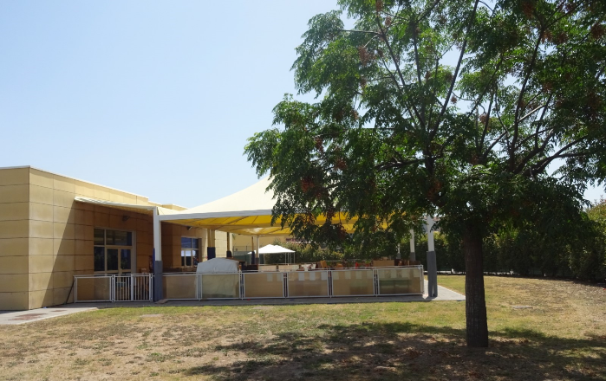

British Forces School Naples (BFS) is located in Lago Patria.  Due to serious and ongoing issues with our old school building, we are currently situated on two adjacent sites. The Early Years Foundation Stage and Key Stage 1 are based in a self-contained building joining the old school building and Key Stage 2 are based in a large Villa at the rear of the old school site. 

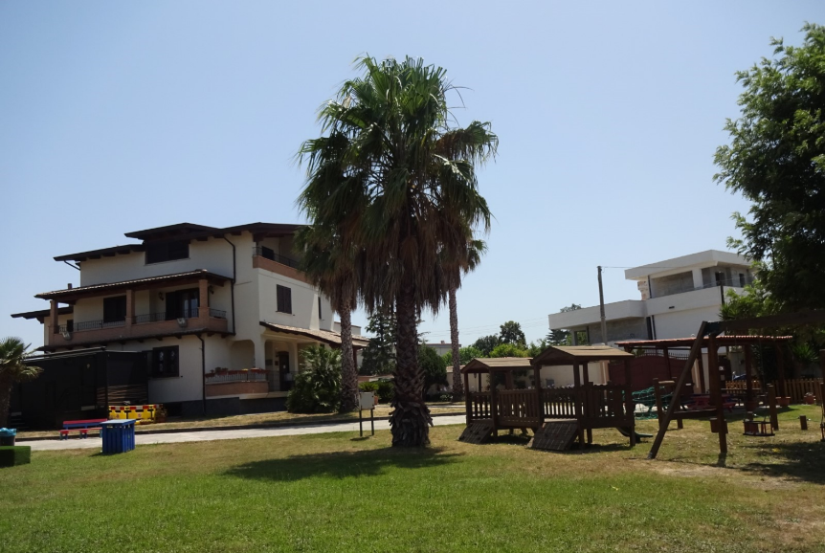

The school is a Primary School with a Foundation Stage (Nursery) Unit to educate children from 3 – 11 years of age when they move to Secondary School.  The Foundation Unit offers places for children from the term after their third birthday for fifteen funded hours per week arranged over five mornings. The school follows the English National Curriculum and is inspected by Ofsted.

**AIMS OF BRITISH FORCES SCHOOL, NAPLES**

At BFS our School Motto and principle aim is:

**Be The Best That You Can Be In All That You Do**

In addition, the school aims in no particular order to promote:

* The development of a child’s lively enquiring mind, imaginatively, creatively and honestly.  To develop the ability to question and discuss matters rationally.
* The acquisition and development of attitudes and skills which encourage learning that is meaningful, enjoyable and relevant, using a broad range of appropriate work and structured play, throughout both key stages, enabling each child to develop to their full potential.
* A planned progression of work throughout the school, building on each child’s individual experience and skill level.
* A sense of responsibility, confidence and independence towards work and behaviour, fostering a child’s feelings of pride and achievement.
* Constructive relationships between home, school and the community based on trust, communication, shared values and understanding.
* Equal opportunities and the positive elimination of gender stereotyping, with understanding and respect of self and others and for different races, religions and cultures, especially the host nation.
* The development of the appropriate skills, knowledge and understanding to have the confidence, creativity and capability to use ICT throughout their lives. We will enable our children/staff to learn about ICT, develop an increasing range of ICT skills and learn how to use them in a range of subjects. We will enable them to become thoughtful and independent users of ICT.
* Experiences which enable pupils to understand that every individual has an important contribution to make to the well-being of the local and wider community.
* Good working relationships between all members of staff where each individual feels valued.

**ADMISSION AND TRANSFERS**

**Admission**

 Pupils entitled to be educated at The British Forces School are dependent primary school aged children of HM Forces or MoD UK Based Civilian personnel posted to Naples on an accompanied tour.  For First Time admissions (FS1) the children can be admitted into the school the term after their third birthday.

Please note because we are a small Rest of World School, we do not have ready access to support for children with Special Educational Needs or Medical Needs.  When a family wish to pursue a posting overseas, the special needs of their child should be declared to CEAS when the posting is offered if the child is not already registered with CEAS.  **For entitled parents of such children it is therefore vital that they liaise with CEAS before any posting action involving being accompanied by the child / children.** CEAS does not make decisions about a child or young person’s education; they advise families and commands to allow them to make informed decisions

The role of CEAS, is to support Service families in obtaining appropriate educational facilities for their children, and to provide high quality information and impartial advice on all aspects of education world-wide, including advice upon special educational needs / additional educational needs.

CEAS's website is: www.mod.uk/defenceinternet/defencefor/servicecommunity/education/childrenseducationadvisoryservice.htm

**The admission procedure is outlined as follows**:

1. Parents should complete the MoD admissions forms (which can be requested from the following email address:  naples.ictadmin@modschools.org) and return them to the School Office in good time before embarkation, ideally at the same time that the family’s application for a quarter is submitted.  The completed application forms can either be scanned or attached to an email sent to the school email address or faxed to the school.  The School checks details from the application to ensure that individual needs can be met and once satisfied issues a Certificate of Education Clearance prior to admission.
2. Parents are encouraged to enrol their child / children on the next available school day following arrival and will need to bring a copy of the child’s birth certificate and any additional documentation given by the previous school (school records, reports and samples of work etc.).

**Transferring to other Schools**

As soon as you know that you are leaving, please inform the school office by completing the leaver form.  This gives us time to complete the necessary transfer documentation.  All school documents, including reports and records of work, will be given to you to take to your child’s new school, and must be signed for in the school office. Please take this with you in your hand luggage rather than your boxes so that you can pass it on to the new school as soon as possible. This will ensure a smooth transfer for your child as the new school will be able to immediately set work at the appropriate level of attainment.  Please note admission procedures in UK schools vary and are localised.  Parents are advised to make enquiries well in advance as to the availability of places in schools and contact CEAS to aid admission (see details above).

**ORGANISATION AND STAFF**

**Organisation**

The school is organised into vertically grouped mixed age classes.  Class sizes vary throughout the school year as pupils tend to arrive and depart throughout the school year accompanying their parents. Within these classes, as is usual in primary schools, the children will work in various groupings from the whole class to mixed/ability groups and individually.  The pupils benefit from excellent teacher/adult to pupil ratios which enable us to cater for the wider age ranges within the same class.

The school employs well qualified and experienced UK qualified teachers many of whom have worked in the UK and other MoD Schools worldwide.  To contribute towards the smooth running of the school, we also employ support staff who are family members of UK Military personnel or of UK Ministry of Defence civilian employees in Naples**.** All staff hold Enhanced Disclosures from the Disclosure and Barring Service in addition all our UK based teachers are cleared to MoD Secret Level (SC) by the DVA in Cheadle Hulme

|  |  |  |
| --- | --- | --- |
| Class | Year group and Age | Class Teacher |
| **Alfa Romeo Class**  (Foundation Stage) | Foundation Stage 1 Age 3 - 4  Foundation Stage 2 Age 5 | **Mrs Clark** |
| **Ferrari Class**  (Key Stage One) | Year 1              Age 6  Year 2 Age 7 | **Mrs Page** |
| **Maserati Class**  (Lower Key Stage Two) | Year 3 Age 8  Year 4 Age 9 | **Miss Coole** |
| **Lamborghini Class**  (Upper Key Stage Two) | Year 5 Age 10  Year 6 Age 11 | **Miss Andrews & Mrs Wortley** |

**CHILD PROTECTION AND SAFEGUARDING CHILDREN**

BFS Naples is committed to the protection and safety of its children.

A copy of our Child Protection and Safeguarding Procedures are available on the website

The school has a Designated Safeguarding Lead – Mrs Robinson (Headteacher)

The school has a Deputy Designated Safeguarding Lead – Mrs Wortley (Assistant Headteacher and SENDCO)

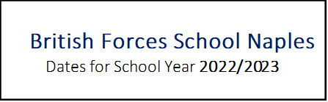

|  |  |
| --- | --- |
| **Autumn Term 2022** | |
| Thursday 1st September | First day of term – staff only |
| Friday 2nd September | Staff Training Day |
| Monday 5th September | First day of term for all pupils |
| Monday 24th October – Friday 28th October | Half Term holiday |
| Friday 16th December | Last day of Autumn Term |

|  |  |
| --- | --- |
| **Spring Term 2023** | |
| Tuesday 3rd January | First day of term – staff only |
| Wednesday 4th January | First day of term for all pupils |
| Monday 13th – Friday 17th February | Half Term holiday |
| Friday 31st March | Last day of Spring Term |

|  |  |
| --- | --- |
| **Summer Term 2023** | |
| Monday 17th April | First day of term  - staff only |
| Tuesday 18th April | First day of term for all pupils |
| Monday 1st May | May Day Bank Holiday |
| Monday 29th May – Friday 2nd June | Half term holiday |
| Thursday 20th July | Last day of Summer Term |

|  |
| --- |
| **Staff Training Days – School Closed for Pupils** |
| Thursday 1st September 2022 |
| Friday 2nd September 2022 |
| Tuesday 3rd January 2023 |
| Monday 17th April 2023 |

**THE SCHOOL DAY**

**The School Day (FS2 – KS2)**

|  |  |
| --- | --- |
| **08:15** | The school gates open for children to start their arrival, including children in FS1. Children are supervised in classes ten minutes before the start of the school day. Children should not arrive before this time. |
| **08:25** | All children to be in class to begin registration |
| **10:10-10:30** | Break time |
| **12:30 – 13:15** | Lunch time |
| **15:05** | The end of the school day |

**FS1** 08:30-11:30 Daily sessions

**Summer Hours**

In the extreme heat of the last few weeks of the summer term the school adopts summer hours. We will let you know the date that the school moves to summer hours through the weekly headteacher update. There is no lunch break during summer ours but a slightly longer break time is given.

**School Day (FS2 – KS2)** 08:25 – 13:00 **Monday - Friday**

**FS1** 08:30 – 11:30   Daily Sessions

**Punctuality**

Children are required to attend school on time and registration starts at 08:25 prompt. Arriving after 08:35 will result in a late mark. Children who arrive after 08:35 will be recorded as “late after the register closes” and this equates to an absence and will affect their attendance figure.

**Transport**

Dedicated School buses are provided by UKNSE for children of serving UK military personnel to get children to and from school. Bus escorts are employed by the UKNSE on each bus to ensure the safety of children. When registering your child, transport arrangements will be fully explained.  Please ensure, before accepting your house that it is within the school bus route boundary.  All children must be taken to and collected from the buses by their parents.  If you arrange for someone else to collect your child from the bus, you will need to write to the senior bus escort giving permission.  If for any reason you are not at the stop to collect your child at the end of the school day they will be returned to school and looked after by staff until they can be safely collected. Please inform the bus escorts, the office and the relevant class teacher if your child’s bus routine changes.  Detailed bus routes with up to date timetables and contact information will be given to you when your child starts school.

**Dogs**

Dogs are not permitted on school premises. Some children are not used to dogs and get anxious when they are in their vicinity; the behaviour of dogs can be unpredictable around crowds and unfamiliar children.

Dogs should not be tied to the school fence or gates.

**Snack**

In Foundation Stage, a mid-morning snack and milk or water is provided for children.  Pupils in Key Stage One and Two have the option of having a snack at morning break which we ask them to bring from home.  We encourage healthy snacks.  Sweets and chocolates are not considered as a suitable snack item.

**Water bottles**

Children are encouraged to bring a water bottle to school, which can be replenished from the water coolers and is available to them throughout the day.  All water bottles should be clearly named.

**Lunch**

We do not have the facilities to provide school meals.  Children in FS2, Yr1 and Yr2 are all entitled to apply for Free School Meals funding through the UKNSE.  All children should bring a packed lunch and drink.  Please provide drinks in cartons or plastic containers, rather than glass containers.  Children are supervised by our Lunchtime Supervisors.

Each Wednesday we are supported by FOBFS (Friends of British Forces School) in running our ‘Pizza Wednesday’. You will receive a letter each term to enable you to order slices of pizza (Margherita or Marinara) at one euro a slice.

**Allergies**

Please be conscious that some children suffer from allergies and for those with a nut allergy it is especially dangerous.  From time to time we have children or staff in school for whom any sort of contact with nuts can be fatal. For their safety, we ask parents not to send in food with nuts e.g. peanut butter, Nutella or Snickers bars, and also to inform their children not to swap their food with anyone else.

**Assembly**

The school meets the statutory requirement to provide a daily Act of Collective Worship that is non-denominational and mainly Christian in character.  Assemblies are led by the Headteacher, a member of staff, the children themselves or a visiting speaker. We also hold weekly Celebrations Assemblies to which parents are invited.  Any parent wishing to withdraw their child from the assembly should put this in writing to the Headteacher.

**School Council**

We have a School Council which is elected by the children for the children.  All the children belong to their Class Council and elections are held for the School Council at the start of the academic year.  The School Council meet regularly following an agenda and report back to the Class Councils.  The Council gets involved in the life of the school and undertakes school projects.

**Extra-Curricular Clubs**

FOBFS support us to enable us to offer a variety of clubs throughout the academic year.

Letters will be sent out with club information and joining instructions during the school year.

**SCHOOL UNIFORM**

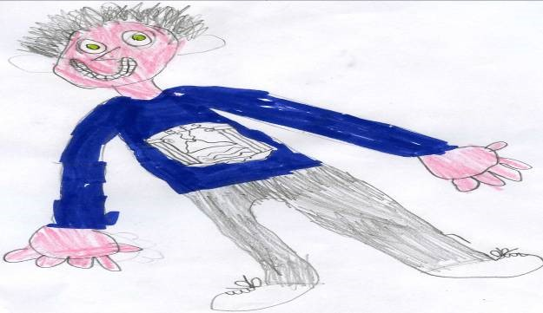**School Uniform**

Whilst school uniform is not compulsory it is strongly encouraged and worn by all pupils creating a school identity and sense of belonging.  Uniform will also be worn on occasions when children are representing the school, including during off-site visits.

 Children are encouraged to wear:

* Grey or black trousers or shorts.
* Grey or black skirts or pinafore dresses.
* White polo shirts
* Blue checked summer dresses
* Suitable school shoes or sandals for summer
* Shorts and T shirt (summer) or track suit (winter) for PE with trainers or plimsolls

**Outerwear**

In winter, children need a warm and waterproof school coat. Children play outside in all weathers so their coats must be appropriate for the weather.

During summer weather, please provide a sun hat with a brim or peak and apply a long-lasting sun protection.

**Footwear**

Shoes should be suitable for school wear, enabling your child to play safely at playtimes. We encourage footwear to be plain black and we recommend shoes that are not a slip-on style as they easily fall off and children are encouraged to be active. Children **must** have a change of footwear for PE.

**Personal Appearance**

Shoulder length and long hair should, for safety and hygiene reasons, should be tied back from the face. Nail varnish, temporary tattoos etc. should not be worn to school.

**Pre-loved Uniform**

 We have a selection of good quality donated uniform (voluntary Euro cash donations received) which are available to view via the school office.  You are advised to bring a good stock of items with you as they can be hard to come by and expensive in Italy.

**All items of clothing must be marked with your child's name**.

**Lost Property**

 A lost property container is located in the hall at Villa V in which all unnamed lost property is placed.

**Valuables/Jewellery**

Please do not send your child to school wearing jewellery as such items can be lost or damaged and it is upsetting for all concerned.  If children have pierced ears, only plain gold or silver studs should be worn. Studs must be removed during all PE lessons; children are expected to remove their own earrings and will be responsible for them so it is preferable not to wear earrings on PE days. The school cannot be held responsible for the loss/damage of children’s belongings unless they have been specifically asked to bring things in.

Many thanks for your cooperation in these matters. We want our children to be smart in their uniform and wear it with pride.

**MEDICAL AND SAFETY**



**First Aid**

The school has a number of First Aid qualified staff to administer first aid.  Minor cuts and bumps are treated in school. A minor injury letter or head bump letter is sent home should your child receive an injury or a bump to the head.  A phone call will also be made in the case of a head injury.

**Sickness and Injury**

The school should always have up to date contact telephone numbers including mobile numbers.  Should a child become ill during school hours we will provide facilities for him or her to rest.  Normally the parents would be contacted by telephone and the matter discussed.  It may be advisable for the child to be collected from school and taken home.

If a child suffers an injury at school and we consider that medical attention is required then the parents will be contacted.  If time is an important factor, we will contact the Doctor at the British Clinic or Medical Centre the Emergency Room of the US Navy Hospital and if necessary transport the child there ourselves.  

Please inform the school if your child contracts an infectious disease such as chicken pox, mumps, and German measles (rubella), which can have serious implications for other children and staff.



Children with diarrhoea and/or vomiting must be kept off school until at least 48 hours after their symptoms have gone. Most cases of diarrhoea and vomiting in children get better without treatment, however if symptoms persist consult the Medical Centre.

**Medicine**

If your child is ill he/she should remain at home.

We aim to ensure that children with medical conditions receive appropriate care and support at school. We do all that is reasonable to ensure that we can administer medication and care to enable them to access school life. The school may only administer medicines prescribed by a doctor.If a child needs to take medicine during school hours, parents should discuss with the school office who will ask them to complete a form giving permission for the medication to be administered.  Any medication that is brought into school should be named and in its original packaging. The child should not bring medicines with them into school.

Children with serious medical conditions or allergies will need a healthcare plan. Please do not hesitate to contact the school office if you have any questions regarding this.

**Asthma**

Inhalers can be brought into school for children who suffer from asthma once an MoD Schools Healthcare plan is completed.  They should be clearly labelled and will be kept in the classroom. The child has access to his/her own inhaler whenever he/she should need it. It is the responsibility of the parent to ensure the inhaler remains in date.

**Head Lice**

From time to time there are outbreaks of head lice among children.  This is quite common but it is important that it is quickly treated. Please check your child’s hair regularly, let us know if your child is observed as having head lice or head lice eggs and do not send your child back to school until he/she is clear.  Parents often become upset when their child gets head lice but in fact it is quite common and nothing to be too worried about providing it is quickly treated.

**Dental and Medical Appointments**

Where possible we ask you to please arrange non-urgent dental and medical appointments out of school hours so that learning is not disrupted. Please do not keep children out of school for the whole day unless necessary.

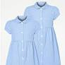**Spare clothing**

A certain amount of spare clothing is kept in school in case of accidents.  It is all clean but may not fit perfectly.  Every effort will be made to make your child comfortable and clean within the limitations of our facilities.  Please wash and return any item of clothing lent to your child.

**Fire Practices**

Regular talks and practices are held and the children know they are to leave the building carefully and assemble in the designated areas.  Information regarding procedures is displayed in all classrooms.

**Earthquake Practices**

Regular talks and practices are held and the children know when they are to leave the building carefully and assemble in the designated areas. Children are taught to ‘Duck, Cover and Hold’ to help protect themselves. Information regarding procedures is displayed in all classrooms.

**Child Protection and Safeguarding procedures.**

The School complies with statutory and MoD Schools guidance on the safeguarding of children.  The school Child Protection and Safeguarding policy is available on the school website.

The school has a Designated Safeguarding Lead – Mrs Robinson (Headteacher)

The school has a Deputy Designated Safeguarding Lead – Mrs Wortley (Assistant Headteacher and SENDCO)

**Attendance**

**Absences from School**

At BFS Naples monitoring of our attendance has demonstrated that good attendance is strongly linked to educational achievement and is extremely important in helping your child to become a happy and successful learner. When a child does not attend school regularly and on time they will have difficulty keeping up with their work and are likely to underachieve. We regularly monitor all absences and the reasons given thoroughly.



Illness is unavoidable so every effort should be made to ensure that your child misses no other school time.  In the event of an illness please contact the school during the morning of the first day of absence. ***This should be done by completing an absence notification on the MySchoolApp***.  If no message is received by the time that the registers close, the school office will endeavour to contact you on the telephone contact numbers given by you. We ask that you endeavour to make routine appointments outside of school hours.  Where this is not possible, you should advise the school in advance of the appointment. ***This should be done by completing an absence notification on the MySchoolApp***.

**Holidays during term time**

The government issued amendments to ‘The Education (Pupil Registration) (England) Regulations 2006.  These amendments came in to force on 1 September 2013. The amendments make it clear that Head Teachers may not grant any leave of absence during term time unless there are ‘exceptional circumstances’.  Therefore, our school will only authorise holidays in line with these regulations.

**They are:**

* 1. **Exceptional circumstances.** Parents can apply to the Headteacher using the Application Form. By definition this is decided upon by the Headteacher on a case by case basis. Examples of ‘exceptional’ would include bereavement or serious illness of relatives, medical needs where treatment is required in the UK by the child’s primary care giver etc. Another example would be where service parents are employed in crucial roles and therefore, to fulfil the needs of the regiment, can’t take leave at the same time as other service parents.
  2. To link with **Rest and Recuperation (R and R) and POL** with a maximum of 10 days. Parents can apply to the Headteacher using the Application Form at Annex B. This application requires the prior signature by a Unit representative, confirming that the parent is *entitled to apply* for term time pupil leave.

Copies of the forms **‘Request for Term Time pupil Leave – Exceptional Circumstances’ and ‘Request for Term Time pupil Leave Pre/ Post Operational Leave (POL)**’ are available at Annex A and B. A full copy of the attendance policy is available on the school website.

**Collection Arrangements**

Children should be collected promptly at 3.30pm. We are unable to send a child home with another adult without prior permission from parents/carers and children will never be sent home with an unknown person. Please ensure that you make the office aware of any changes to your usual collection arrangements and who you are authorising to collect your child. If you are unexpectedly unable to pick up your child, please notify the school by telephone. The school will require the person collecting your child to provide a password that you have been given by the office staff. Pupils will not be handed over to people under the age of 16 unless a written agreement is made with the school. With written parental permission, pupils in Years 5 and 6 may go home alone.

**Curriculum**

**English**

At British Forces School Naples, we believe that a quality English curriculum should develop children’s love of reading, writing and discussion. To support planning, we use *No Nonsense Literacy*: Teaching Sequences for Writing which are a series of stimulating, hands-on learning activities based on high-quality texts that model effective and exciting writing to develop reading, writing, listening and grammar skills. Children have the opportunity to read to an adult at school on a regular basis. In addition to this, class teachers listen to groups of children read in a’ guided reading group’ or together as a whole class. Throughout our guided reading sessions, children develop a range of reading skills through the use of ‘VIPERS’. Our teaching of phonics through *Read Write Inc Phonics* continues into Key Stage 1 and children progress to Read Write Inc Spelling when they have completed the phonics programme. There are also many cross-curricular English opportunities through our use of Cornerstones which exposes children to rich, challenging texts and gives them the opportunity to write across a range of genres that link to their learning.

**Maths**

At British Forces School Naples, we aim for all children to become resilient, fluent mathematicians with an ability to tackle problem solving and take on maths in the real world. To ensure consistency and progression, we use the White Rose Maths scheme throughout our school. White Rose premium resources and NCETM materials are used to support planning and resourcing.

**The Cornerstones Curriculum – History, Geography, Art and DT**

At British Forces School Naples we have adopted the [Cornerstones Curriculum for the teaching of History, Geography, Art and DT.](https://cornerstoneseducation.co.uk/)We use this as a basis for our structure and within this very much understand the importance of personalising the curriculum to our children, our setting and our unique community

Cornerstones Curriculum is delivered through a range of inspirational yet rigorous learning projects that allow children to learn in a way that motivates and interests them. These are based on the National Curriculum, but bring learning together in new and exciting ways. Each project combines different strands of learning so that children learn more holistically and start to challenge themselves and learn problem solving skills as they create truly fantastic learning opportunities. Cornerstones provides our children with a good level of challenge, giving them opportunities to solve problems, apply themselves creatively and express their knowledge and understanding. The content of our curriculum is broad, varied and engaging and covers all statutory content set out in the subject programmes of study. In Years 1 to 6, curriculum content is organised into a range of driver projects and companion projects. Driver projects span a half-term and, where there are companion projects, these are woven into the half-term plan. Companion projects are subject-focused for art and design and design technology.

**Science**

In Key Stage 1 and 2, lessons are planned using the Active Learn ‘Science Bug’ schemes of work and/or Cornerstones Science Knowledge Rich Projects. This ensures that all topics are covered and enables progression through the year groups.

Our teaching of Science is planned to ensure all pupils:

* develop lively, enquiring minds and the ability to question.
* learn scientific skills and knowledge with progression throughout the Key Stages.
* build on their natural curiosity; enabling them to understand and care for the world in which they live.
* are provided with a stimulating environment, where they can work in an investigative way and can communicate their findings in a variety of ways.
* learn to use equipment safely and sensibly.
* develop potential scientific links with all other areas of the curriculum.

**Computing**

Within both KS1 and KS2 the computing curriculum should be covered primarily through day-day teaching and making use of the range of technology which is available within school.

Across Key Stages 1 and 2, a weekly computing session is timetabled for each class. In this session there is a focus on contextual skill development and these sessions provide experiences which can then be applied in other work.

At British Forces School Naples, we use the ‘Rising Stars – Switched on Computing’ Scheme of work, focusing on Digital Literacy, Information Technology and Computer Science. To help ensure children have the opportunity to develop a wide range of skills, experiences and competencies with technology, the curriculum has been broken down into 6 key areas, with the core principles permeating through each area.

* Algorithms
* Programming & Development
* Data & Data Representation
* Hardware & Processing
* Communications & Networks
* Information Technology

**Music**

At British Forces School Naples, we believe that Music is a unique way of communicating which can inspire and motivate children. It is a vehicle for personal expression and plays an important role in the personal development of each child. Music reflects culture and society and so the teaching and learning of music enables children to better understand the world they live in. It also plays an important role in helping children feel part of a community.

We use Music Express, a published scheme of work, to deliver the National Curriculum for Key Stage 1 and 2. The scheme of work is flexible, creative and makes cross curricular links. The range of resources within Music Express supports teachers who are non-specialists.

**PSHE**

The skills taught in PSHE enable pupils to develop the skills they need to flourish in the wider curriculum and in life as a whole. PSHE helps pupils to understand their own personal value, and how as individuals, they fit into and contribute to the world. PSHE helps to develop emotional literacy, build resilience and supports mental and physical wellbeing, in turn supporting emotional awareness, concentration and focus.

To ensure a depth and accuracy of learning which builds upon prior learning, all classes undertake weekly PSHE lessons which follow Jigsaw 3-11, a fully planned and spiralling/progressive PSHE scheme. As a school, we follow a set theme each half term, which is introduced, in a whole school assembly. Lessons are underpinned by the Jigsaw behaviour charter, which reinforces respect for each other – taking turns, being kind and positive and respecting confidentiality.

**PE**

For our PE curriculum, we meet National Curriculum expectations for PE through our use of the **Rising Stars Champions PE Scheme.** Champions is a Sports, Fitness and Health programme for Years 1 to 6. It is a holistic approach to the teaching of PE, which improves fitness, develops skills and deepens knowledge of health and wellbeing. The Sports and Fitness lessons are covered in twice weekly PE slots and the Health lessons can be taught in one of the PE sessions, a science or PSHE lesson or in a carpet time or discussion with the children.

**Modern Foreign Languages (MFL) - Italian**

We aspire in teaching MFL at British Forces School Naples to foster an interest and enjoyment in learning a language and an enthusiasm to find out about the different cultures around the world. MFL is taught as a discrete subject and is taught through Italian. It is taught twice weekly for approximately fifteen to thirty minutes depending on the age of cohort, by our locally employed Italian tutor.

**EYFS**

The EYFS curriculum is exciting and motivating, capturing a love of learning at the start of a child’s education. All learning covers the seven areas stated in the EYFS framework. There is a key focus on language and communication, early literacy and mathematics, and personal, social and emotional development.

**Special events and educational visits**

Throughout the year, theme weeks are held such as Anti-bullying, Enterprise, Creative Arts and Eco Week.  These opportunities further enhance the curriculum for children and bring learning to life.   In addition, class teachers organise a range of educational visits as part of the curriculum theme examples of which include the fire station, hospital, Cuma, Herculaneum, Coast of Naples etc. Trips and visits enrich the curriculum for all children and support their personal and social development. Details will be communicated to you via letter before each planned trip or visit. Voluntary contributions may be requested to help fund these enrichment activities.

**Home Learning**

We want children to develop a sense of responsibility for their learning and to think independently. Home learning provides a regular three-way link between child, parent and class teacher.

Home learning enhances, consolidates and supports children’s learning in school.

Your child’s home learning will be set weekly via e-Schools with additional worksheets/activities sent home.  Home Learning is usually set each Thursday as it to be returned the following Wednesday. Home learning activities will take place in various forms such as; joint family activities, consolidation activities, challenge worksheets, spellings, topic tasks, research and projects. Each year group will set their own home learning activities, and these will differ as the children grow through the school.

A copy of the school’s Home Learning policy is available from the school website. Home learning should not be too onerous and neither should it disrupt family life. If parents have any concerns about the home learning that has been set, they should not hesitate in contacting their child’s class teacher.

**Reading**

Developing a love of reading is a priority for us at British Forces School Naples because research shows that there is a direct link between a child’s enjoyment of reading and their reading attainment. We also place a great importance on reading because it is fundamental to all education as it is used as a mechanism to teach all other subjects.

As parents, you play a vital role in supporting your child to read. By reading with your child at home, you will help support their reading progress and development as well fostering positive attitudes towards reading.

You can help your child to achieve their full potential by listening to them read daily, reading regular bedtime stories and by encouraging them to enjoy reading and sharing books together. Reading widely through all of these approaches will help develop your child’s vocabulary, which in turn will make them more confident when reading more challenging books.



At the beginning of the year your child will bring home their first set of reading books, a Reading Record for you to record reading activity and a reading wallet to store their items and to carry them safely between home and school.

Please read with your child at least 5 times per week for a minimum of 15 minutes and record this in your child’s Reading Record along with a brief comment.

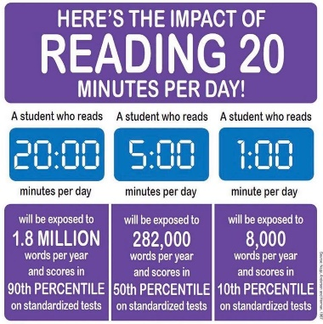It is acceptable for older pupils to record their own reading experiences in their diaries but it would be helpful to have these comments also signed by an adult when you check and hear them read. It is still expected that pupils in Key Stage 2 will be heard read aloud although not necessarily every page of their reading book and it is crucial for pupils in Key Stage 2 to be questioned about their reading and given opportunities to discuss new vocabulary. Your support with reading at home is essential and only by working together can we ensure your child achieves their potential as a reader. If you require any further guidance regarding reading, please ask your child’s class teacher.

**Behaviour**

**Approach**

At BFS we use a system of behaviour management that focuses on positive behaviour management strategies.  We encourage all of our pupils to manage their own behaviour. Our school ethos is underpinned by the desire to enable our children to successfully manage their own behaviour by embracing our school motto, adhering to our school rules and displaying our Learning Behaviours. The school has a very positive and friendly atmosphere.  We aim to foster good manners, respect and responsibility. We rarely have consistent or extreme bad behaviour, including bullying, but if it is exhibited by a child then the parents of this child would be invited to the school to discuss the matter.

We enable our pupils to actively manage their own behaviour in several ways:

* By knowing our children well and forging positive relationships with all pupils
* Through active promotion of our school rules and expectations through assemblies and in class PSHE lessons through active promotion of our Learning Behaviours
* Through active promotion of our school motto
* Awarding children with House Points when they make good choices
* Awarding our Star of the Week certificate to a pupil in each class every week with a particular focus on our Learning Behaviours
* Inviting children to attend Headteacher Tea Parties when they have demonstrated our School Rules and Learning Behaviours
* Being consistent with the consequences for poor behaviour choices
* Having clear routines and class boundaries
* Actively including the children in discussions about their behaviour and involving them in determining any consequences for poor behaviour

**The Orange Card System**

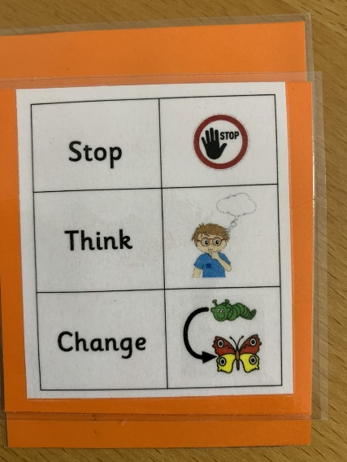To address low-level disruptive behaviour and enable the children to manage their own behaviour, we operate an Orange Card system in school. If a child is displaying low-level disruptive behaviour, they are handed a school Orange Card. The Card contains 3 words and accompanying pictures: Stop, Think, Change. The card is given in silence to allow learning to continue. This visual prompt allows the child to amend their behaviour and if the child successfully changes their behaviour, the card is removed. If the behaviour continues once a card has been issued and the child is not able to amend their behaviour, the child will lose Golden Time in class. Each week the children who lose Golden Time will spend time with the HT to discuss what happened and consider what they will do to try and prevent it from happening again. Loss of Golden Time will be tracked and monitored by the HT. If patterns emerge, parents will be contacted with a view to discussing further support.

The Orange Cards are used by all members of staff and can be used both inside and outside. When the children are at play, if an Orange Card is issued it will result in a 5-minute time out, after which they can then return to their play. If they are unable to successfully return to their play, their teacher will be informed and they will lose 5 minutes of their Golden Time.

**School Rules**

The school follows a set of ‘Super School Rules’ which were created by the children and are shared regularly.  The Super School Rules are displayed in the classrooms and throughout the school.  These are reinforced through the PSHE Curriculum, reward systems operated in each class and Celebrations Assembly where children are rewarded for demonstrating good behaviour, attitude to learning and achievement.  Our Super School Rules are:

* We use kind hands and kind feet
* We respect everyone and everything
* We always try our best
* We are polite and use good manners
* We are honest

**Learning Behaviours**

Across the school, we have six different learning behaviours that we focus on so that we can become the best learners that we can be (one learning behaviour for each half term). Each of our learning behaviours is represented by an animal. This helps us to remember them all. Together, we have created a list of what each learning behaviour looks like and we regularly talk about this in class and in our assemblies. 

**A copy of our learning behaviours can be found in Appendix D.**

A copy of the Managing Behaviour policy is available on the school website

**House Teams** 

On arrival at BFS Naples, the children are allocated a house team. There are three house teams which are: Etna, Vesuvius and Stromboli. House points are earned through demonstrating our Learning Behaviours and during events such as Sports Day. Each week we share our house points in our celebration assemblies. 

**Anti-bullying**

We consider ourselves fortunate that bullying is not a feature of our school.   We take seriously and investigate any child perceived allegation.  We don’t allow unkind or cruel behaviour in our school.   But not all unkind behaviour is bullying.  The key characteristics that turn unkindness into bullying are:

* that it is repeated and goes on over time;
* that it is deliberate and not accidental;
* that it involves the person doing the bullying in having some sort of power over the person experiencing the bullying.

Parents who are concerned that their child might be being bullied, or who suspect that their child may be the perpetrator of bullying, should contact their child’s class teacher immediately.

Parents have a responsibility to support the school’s anti-bullying policy and to actively encourage their child to be a positive member of the school.

We have a duty of care to ensure our young learners are empowered to tackle bullying should it ever occur (including once they are posted from Naples).  As such, we raise awareness through participating in National anti-bullying week and as appropriate during assemblies, Circle Time and other classroom activities.  

**SEND**

We are a very small ‘Rest of World’ school and do not have ready access to support for children with Special Educational Needs or Medical Needs (see the admissions section above re: admissions of children with special needs)

Where children have needs that can be met within the school’s resources, these are managed in the classroom environment and in full co-operation with parents. There is a Special Educational Needs Co-ordinator on the staff whose responsibility it is to support the class teacher in dealing with children who have identified special needs. All children with SEND are taught in mainstream classes and their needs are met by the production of an Individual Learning Plan (ILP). These may be supported in class by a learning support assistant (LSA) in addition to the class teacher. Parents are always informed if an ILP is drawn up and invited to school to discuss its contents and to offer support at home

Where on-going needs prove / become more significant, the school will follow the MoD Schools SEND policy and involve outside agencies such as Speech and language therapist, Educational Psychologist as required with the parents knowledge and agreement.  In some cases, due to the location of the school a decision may have to be made regarding whether the pupil’s ongoing needs can be met at The British Forces School.

Our policy is in line with the UK Code of Practice which gives guidance and lays down specific stages of Special Needs.  Parents are fully informed and involved at each stage of the process and your permission is sought prior to requesting advice from an Educational Psychologist or Child Guidance Service.  **It is important that the school is informed of any previous support your child has had, or any concerns you may have, so that we can continue to meet your child's needs.**

For further information, a copy of the MOD SEND offer, SEND information report and SEND policy are available on the school website.

**Pastoral Support**

All members of staff play a significant role in providing a high level of pastoral support in the school. The school has a number of adults who provide specialist WELSA support. Our trained WELSAs (Wellbeing + Emotional Literacy Support Assistants) plan and deliver individualised programs of support for children to develop their emotional literacy and to small groups of children to develop social and friendship skills. Our WELSAs access regular clinical supervision for an Educational Psychologist which enables wider groups of children to access quality, targeted, evidence-based support.

**FRIENDS OF THE BRITISH FORCES SCHOOL (FoBFS)**

The Friends of the British Forces School is a very active committee which mirrors a parent/teacher association.  By fund raising through a number of charitable events, FoBFS helps to provide equipment for the benefit of our children, which the school would otherwise be unable to provide. News of activities organised by this committee is circulated by the School. All parents automatically become members of FoBFS and the Chair always welcomes new members to the Committee. Please contact the school office for more information if you would like to be involved.

**Parent Helpers**

We welcome offers from parents and other adults who are willing to volunteer to help with school activities such as cookery, reading, group activities, accompanying children on outings and visits.

All regular helpers require a DBS check prior to volunteering.

If you are interested, please speak with your child’s class teacher or contact the school office.

**School Fund**

The School Fund is a small “non-public” fund used to purchase some locally obtained consumables as part of the curriculum such as cooking ingredients etc.  Fundraising activities take place from time to time to purchase extra equipment for the children’s use and for some day-to-day expenses.

**SGC**

Every MoD School has a School Governance Committee (SGC).  The SGC is a team of people who work to improve the outcomes for the children.

Areas of interest for the Committee are expected to follow broadly those that are discussed at meetings of Board of Governors in the UK.  It is consulted in such matters as:

* Priorities in the School Improvement Plan.
* Standards
* Head Teachers proposals for the allocation of the schools delegated budget.
* Review of OFSTED Reports and other external inspections.
* Whole School Policy.
* Sensitive or potentially controversial matters involving the school.

 Please contact the school for details of the current SGC members or if you would like to become a Parent Representative when the next vacancy arises.

**Home and School Liaison**

**Home School Contact**

We operate an open-door policy and as such parents are welcome to come into school at anytime.  Generally speaking, the start of the day is very busy and whilst teachers will be available, it may not be the best time for a detailed discussion.  Where parents need to share key information that is relevant for the day ahead, this is appropriately shared on arrival in the morning.  Otherwise parents are encouraged to make an after-school appointment when the matter can receive the undivided attention of the teacher.

**MySchoolApp**

This is our primary communication tool for newsletters, messages, trip letters etc. The calendar will provide an at-a-glance view of upcoming events. Parent/Carers can complete an absence reporting form on the app to inform the school office of any absences. Push notifications are used to send out reminders and quick messages.

**Headteacher Updates**

A weekly newsletter is sent home via MySchool App. All parents will be invited to join the App when they arrive.

**Telephone the school**

Where parents need to contact the school during the day they are welcome to telephone the school to provide information or make an appointment. Please call on the following number: 0039 3475103211.  You can also contact the school via the following email: naples.office@modschools.org

**Parent Consultations**

The school arranges Parent Consultation meetings in Term 1 and Term 2 to discuss individual pupil progress.  Additionally, an annual report will be written on the progress of you child during the academic year.

**ESchools**

All children have an ESchool account and this is where teachers will upload homework, messages for the class and an overview of learning.

**Reading Record**

This keeps parents/carers informed of reading progress.

**Website**

Our school website holds a host of information including term dates, policies, links to online tools, weekly class blogs, curriculum information and much more.

**Keeping contact details up-to-date**

If for any reason your home, mobile or work number should change, please let us know as soon as possible so that we can ensure our contact details are always up-to-date. 

**COMPLAINTS PROCEDURE**

We believe that our school provides a good education for all our children, and that the staff work very hard to build positive relationships with all parents.  However, the school is obliged to have procedures in place in case there are complaints by parents.

1. If a parent is concerned about anything to do with the education that we are providing at our school, they should, in the first instance, discuss the matter with their child’s class teacher.  Most matters of concern can be dealt with in this way. All teachers work very hard to ensure that each child is happy at school, and are making good progress; they always want to know if there is a problem, so that they can take action before the problem seriously affects the child’s progress.

1. Where a parent feels that a situation has not been resolved through contact with the class teacher, they should make an appointment to discuss the matter with the Assistant Headteacher.  Most complaints are normally resolved at this stage.

1. In the rare event that the situation has not been resolved through contact with the Assistant Headteacher, they should complete a complaints form available from the School and make an appointment to discuss it with the Headteacher.  The Headteacher considers any such complaint very seriously and investigates each case thoroughly.  Most complaints are normally resolved at this stage.

1. In the rare event that the situation has not been resolved through contact with the Headteacher, they should complete a complaints form to refer the matter to the Complaints Sub-Committee of the SGC using the complaints form. This Sub-Committee (which must not include the Headteacher or any staff member) will consider the complaint accordingly.

The extant Complaints Procedure for MOD Schools issued by Directorate Children and Young People (DCYP)  is available on the School website and a paper copy can be provided on request.

**Annex A: Term Time Leave – Exceptional Circumstances**

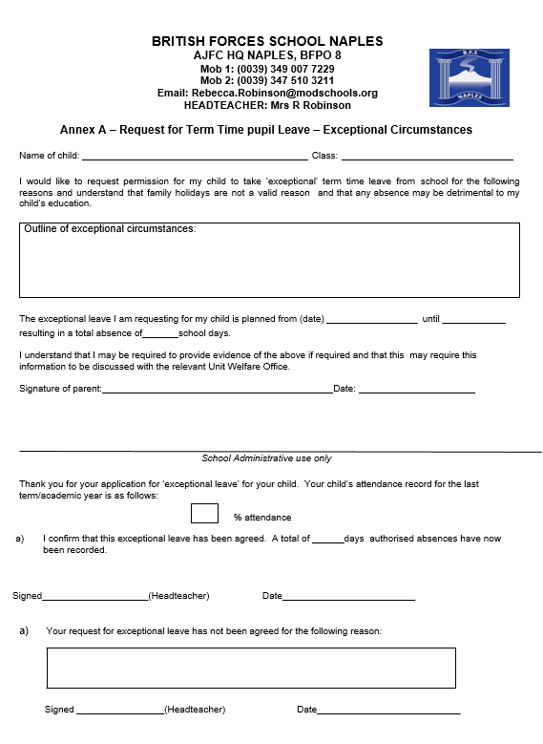

**Annex B: Term Time Leave – Pre/Post Operational Leave**

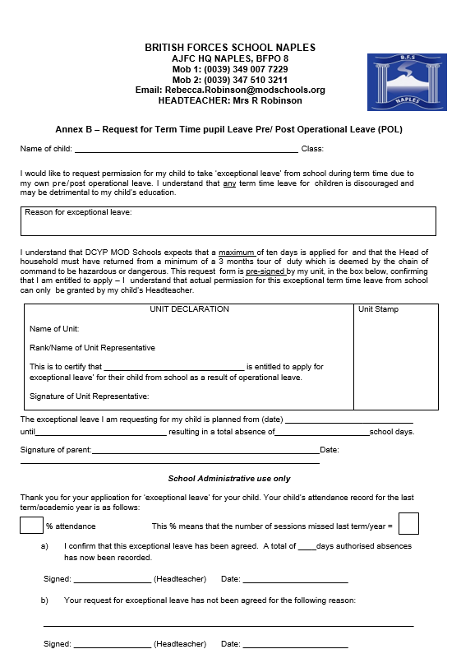

**Annex C: Top Ten Tips for Reading**

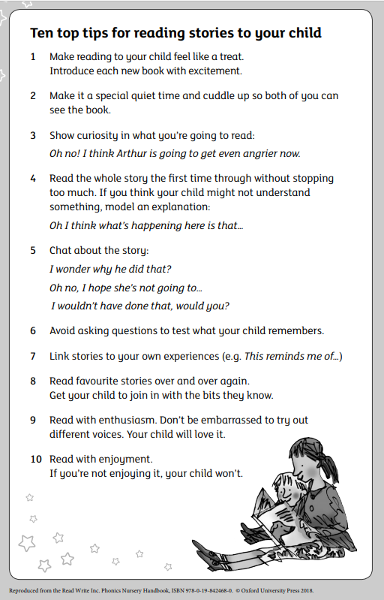

**Annex D: Learning Behaviours**

|  |  |  |
| --- | --- | --- |
| **What do I believe?** | **What would you see me do?** | **What would you hear me say?** |
| **C:\Users\wortleyl51\AppData\Local\Microsoft\Windows\INetCache\Content.MSO\D60AC3B.tmp**  **Term 1.1: Italian Bee** | **Motivated Learner**  **I am an active and motivated learner.** | |
| I can take initiative with my learning.  I take pride in my work.  I want to get involved.  I am enthusiastic about learning. | Fully involved in a task  On task  Actively seeking new knowledge  Actively engaging with new challenges | “I need to know.”  “Can I share/ show my learning?”  “Can I find out about..?”  “My targets are…” |
| **C:\Users\wortleyl51\AppData\Local\Microsoft\Windows\INetCache\Content.MSO\8CB84D01.tmp**  **Term 1.2: Striped Dolphin** | **Collaborative Learner**  **I work well with others.** | |
| I can share my ideas and opinions with others.  I respect and value everyone’s ideas.  I can listen and respond positively to the ideas of others.  I work responsively as part of a team. | Working with others  Listening to others  Responding to others  Changing actions in response to others’ ideas | “I am sharing.”  “I am listening to others.”  “I hadn’t thought of that.”  “Let’s work together.” |
| **C:\Users\wortleyl51\AppData\Local\Microsoft\Windows\INetCache\Content.MSO\10A897B7.tmp**  **Term 2.1: Scillian Pond Turtle** | **Resilient Learner**  **I never, never, never give up!** | |
| I know it’s ok to get things wrong.  I can learn from my mistakes.  I take risks and I’m willing to try new things.  I can challenge myself. | Taking risks  Accepting mistakes  Embracing challenge  Staying positive | “How can I?”  “I will change the way I do this.”  “I will have a go.”  “I won’t give up.” |
| **C:\Users\wortleyl51\AppData\Local\Microsoft\Windows\INetCache\Content.MSO\36F351DD.tmp**  **Term 2.2: Little Owl** | **Thoughtful Learner**  **I am a critical and creative thinker.** | |
| I can think of ideas.  I can think of new ways to do things.  I can always learn something new.  I can make links between my learning. | Adapting an approach  Questionning  Exploring and Predicting  Applying their learning in new ways | “What about…”  “I think…”  “Why?”  “How/ How else?” |
| **C:\Users\wortleyl51\AppData\Local\Microsoft\Windows\INetCache\Content.MSO\7B7DDCF3.tmp**  **Term 3.1: Red Squirrel** | **Reflective Learner**  **I can improve my learning.** | |
| I can always improve.  I can identify how to make improvements.  I have high expectations of myself.  I can learn from others. | Wanting to find ways to improve  Adapting their learning based on the ideas of themselves or others  Having high expectations  Showing pride in their achievements | “I can use this.”  “What might be better is…”  “This has gone well.”  “My next step will be.” |
| **C:\Users\wortleyl51\AppData\Local\Microsoft\Windows\INetCache\Content.MSO\EBBF9679.tmp**  **Term 3.2: Marsican Brown Bear** | **Independent Learner**  **I can be independent in my learning.** | |
| I can help myself.  I find ways to solve the problem.  I know when and who to ask.  I take responsibility for my learning. | * Working alone * Focusing on my learning * Solving problems * Following instructions | “I can have a go by myself.”  “I can do it.”  “I know how to find out.”  “What happens if?” |

BRITISH FORCES SCHOOL NAPLES



**Defence Children’s Services**

**Ministry of Defence Schools**

**Privacy Notice**



**Privacy Notice (How we use pupil information)**



This privacy notice lets you know what happens to any personal data that you give to us, or any that we may collect from or about pupils and explains how we collect and process this to meet our obligations.

This privacy notice applies to your personal data processed by or on behalf of Directorate Children and Young People.

This Notice explains:

1. **Introduction**
2. **The categories of personal data we collect and use**
3. **The legal basis for processing pupil’s personal data**
4. **Why we collect and use this personal data**
5. **How else we may use personal data**
6. **Change of Purpose**
7. **Keeping personal data safe and secure**
8. **Who we share pupil personal data with**
9. **Transferring data internationally**
10. **Your Rights**
11. **Complaints, Objections and Contacts**

**1. Introduction**

The General Data Protection Regulation (GDPR) and the Data Protection Act 2018 (DPA18) form the legal framework for protecting personal data.

We will comply with the data protection principles set out in the GDPR. These say that the personal data we hold about you must be:

* Used lawfully, fairly and in a transparent way.
* Collected only for valid purposes that we have clearly explained to you and not used in any way that is incompatible with those purposes.
* Relevant to the purposes we have told you about and limited only to those purposes.
* Accurate and kept up to date.
* Kept in a form which permits individuals to be identified only as long as necessary for the purposes we have told you about.
* Kept securely.

The Ministry of Defence is that data controller for all personal data that we hold about pupils. Contact details are at the end of this notice.

**2. The categories of personal data that we collect, hold and share about pupils include:**

* Personal information (such as name, unique pupil number and address);
* Characteristics (such as ethnicity, language, nationality, country of birth and free school meal eligibility);
* Attendance information (such as sessions attended, number of absences and absence reasons);
* Assessment information;
* Relevant medical information;
* Special educational needs and disabilities information;
* Exclusions/behavioural information;
* Previous schools;
* Safeguarding information.

**3. The legal basis on which we process personal data**

The legal basis under which we process pupil personal data is as follows;

* To comply with our legal obligation (Article 6 c)
* To perform tasks carried out in the public interest or in the exercise of official authority ( Article 6 e)
* To protect vital interests where the data subject is physically or legally incapable of providing consent
* For “special categories” of personal data (such as racial or ethnic origin and health data) under Article 9b and Article 9c

**Data collection requirements**

To find out more about the data collection requirements placed on us by the Department for Education (for example; via the school census) go to <https://www.gov.ukeducation/data-collection-and-censuses-for-schools>

**4. Why we collect and use this personal data:**

We use the personal data:

* To support pupil learning;
* To monitor and report on pupil progress;
* To provide appropriate pastoral care;
* To assess the quality of our services;
* To comply with our legal obligations.

**5. How else we may use personal data**

Whilst the majority of pupil personal data you provide us is mandatory, some of it is provided to us on a voluntary basis. In order to comply with Data Protection legislation, we will inform you whether you are required to provide certain pupil information to us or if you have a choice in this.

**6. Change of purpose**

We will only use personal data for the purposes for which we collected it, unless we reasonably consider that we need to use it for another reason and that reason is compatible with the original purpose. If we need to use the personal data for an unrelated or new purpose, we will notify you and we will explain the legal basis which allows us to do so.

**7. Keeping personal data safe and secure**

We hold pupil data for 75 years if related to safeguarding casework; non-safeguarding pupil casework is held for 25 years. We operate controlled access to this information on a “need to know” only basis which is reviewed quarterly.

**8. Who we share pupil information with**

We routinely share pupil information with:

* Schools that the pupils attend after leaving us;
* The Department for Education;
* Other parts of the Directorate Children and Young People;
* Health or Safeguarding agencies to comply with our regulatory and legal responsibilities.

We do not share information about our pupils with anyone without consent unless the law and our policies allow us to do so.

We share pupil’s data with the Department for Education, (DfE), on a statutory basis. This data sharing underpins educational attainment policy and monitoring.

**9. Transferring data internationally**

Where we transfer personal data to a country or territory outside of the European Economic Area, we will do so in accordance with data protection law.

**10. Your Rights**

Under data protection legislation, parents and pupils have the right to request access to information about them that we hold. To make a request for your personal information, or be given access to your child’s education record contact the school office in the first instance and mark your request FAO data protection admin.

Parents and pupils also have the right to:

* **Correction** of your personal data. This enables you to have any incomplete or inaccurate data we hold to be corrected.
* **Request erasure** of your personal data. This enables you to ask us to delete or remove personal data where there is no good reason for us continuing to process it. You also have the right to ask us to delete or remove your personal data where you have exercised your right to object to processing.
* **Object to processing** of your personal data where there is something about your situation which makes you want to object to processing on this ground.
* **Request the restriction of processing** of your personal data. This enables you to ask us to suspend the processing of personal data about you, for example if you want us to establish its accuracy or the reason for processing it.

There are some exceptions to the rights referred to above. Details of such restrictions will be provided to you if relevant.

* **Right to withdraw consent** - In the limited circumstances where you have provided your consent to the collection, processing and transfer of your personal data for a specific purpose, you have the right to withdraw your consent for that specific processing at any time.

You will not have to pay a fee to access your personal data (or to exercise any of the other rights). However, we are allowed under the law to charge a reasonable fee if your request for access is clearly unfounded or excessive. Alternatively, we can refuse to comply with the request in such circumstances.

To comply with your request, we sometimes need to ask for specific information from you to help us confirm your identity and ensure your right to access the personal data (or to exercise any of your other rights). This is another appropriate security measure to ensure that personal data is not disclosed to any person who has no right to receive it.

Further information can be found at: <https://ico.org.uk/for-organisations/guide-to-the-general-data-protection-regulation-gdpr/individual-rights/>

**11. Complaints and Contact information**

We take any complaints about our collection and use of personal information very seriously. If you think that our collection or use of personal information is unfair, misleading or inappropriate, or have any other concern about our data processing, please raise this with us in the first instance.

To make a complaint, please contact our **data protection champion** (details below):

Data Protection Champion,

Defence childrens services,

Trenchard Lines,

UPAVON, Wilts, SN9 6BE.

Email: [dcyp-dcyp-mailbox@mod.uk](mailto:dcyp-dcyp-mailbox@mod.uk) - please mark ‘FAO: Data Protection Champion’ in the subject title of your email.

**Contact Us**

If you have any questions, concerns or would like more information about anything mentioned in this privacy notice, please in the first instance contact the school office of the school your child attends.

The Ministry of Defence Data Protection Officer contact details are as shown below if you have exhausted all other avenues:

MOD Data Protection Officer

Ground Floor, Zone D

Main Building

Whitehall

London SW12 2HB

Email: cio-dpa@mod.gov.uk

**Annex F: Information Booklet for Parents**

**Checklist of forms to return to the office**

|  |  |
| --- | --- |
| **Document Details** | **Complete** |
| Emergency Contact Form |  |
| GDPR Consent Form |  |
| Homework Agreement Form |  |
| Online Working Form |  |
| Pizza Wednesday Participation Form |  |
| Target Tracker Form (FS1 and 2 Only) |  |

**These forms will be given to you as part of the Welcome Pack when your child starts at the School. If you can ensure these forms are completed at your earliest convenience and returned via your child to their Class Teacher, it will be very much appreciated.**