Read Write Inc.
Parent Information Booklet
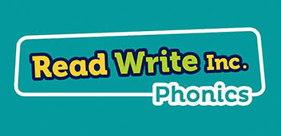

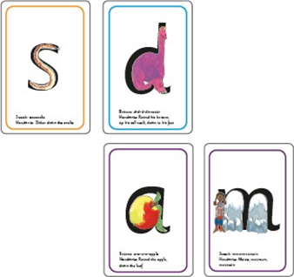
What is Read Write Inc Phonics?
Read Write Inc. (RWI) Phonics is a DfE-validated systematic synthetic phonics programme with a whole-school approach to teaching early reading and writing, designed to ensure progress for every child, in every primary school.
The aim of RWI Phonics is for children to learn to read early. They also learn how to form letters using mnemonics to help them and they learn to spell correctly using their Fred fingers.
RWI is taught through daily phonic lessons where we teach sounds and children practise reading and spelling words containing these sounds.
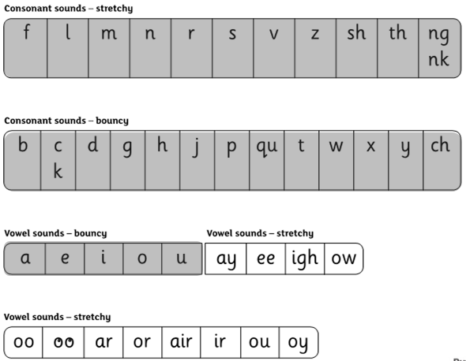
Each child is carefully assessed and placed into a RWI group based on their phonics sound knowledge and reading skills. This ensures that all children are working at the right level for their ability which is the best way to ensure progress and confidence in their reading skills. Groups are assessed every half term (approximately 6 weeks) and children are moved accordingly to either accelerate progress or provide further consolidation. Those children not making sufficient progress will be given targeted in-class intervention.
What are speed sounds?
Children are taught the early sounds in Set 1. This covers the alphabet and a few ‘special friends’ which are two letters which make one sound such as ‘sh’. They will learn to spot and recognise them quickly through fun activities and also to write them using ‘phrases’ to help them remember the correct formation. We teach children ‘pure sounds’ which can be heard using https://www.youtube.com/watch?v=TkXcabDUg7Q. It is important to remember that children need to know sounds – not letter names – to read words.

What is Fred Talk?
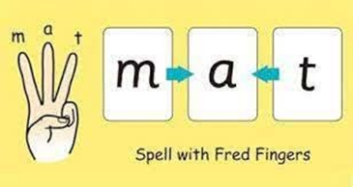
Alongside teaching children sounds, we teach children to blend sounds to read words e.g. s-a-t, sat.
We use Fred Talk to help children read. Fred can only speak in sounds. He says d-o-g, h-a-t etc. Speaking like Fred helps children to understand that words are made up of sounds.
Fred helps children practise blending sounds together because he needs the children to say the words for him. Fred says d-o-g, children tell him the word is dog. This is how we quickly teach all of our children to blend.
What happens after children know their Set 1 sounds?
When children are confident with blending and know all of their Set 1 sounds, the children will move onto Set 2 sounds and then Set 3 sounds, which introduce alternative spellings for sounds they know and more special friends.
Set 2 Speed Sounds: ay ee igh ow oo oo ar or air ir ou oy and words containing these sounds
Set 3 Speed Sounds: ea oi a-e i-e o-e u-e aw are ur er ow ai oa ew ire ear ure and words containing these sounds
They may begin to use ‘Fred in their head’ to read more quickly and fluently, which helps to build up speed, however this stage is also tricky for children as they need to be able to spot ‘special friends’ easily within new words.
What are ‘red’ and ‘green’ words?
Words which can be decoded are called ‘Green Words’ as they can be deciphered using phonics knowledge. Unfortunately, there are lots of words in the English language that do not follow these rules … they are called ‘Red Words’ or tricky words and need to be learned by sight. We use the phrase ‘You can’t Fred a red’ to remind children.
When faced with an unfamiliar word we use the phrase ‘Special friends – Fred talk – Read the word’ as this reminds them that it is important to spot the special friends before attempting to read the word. To further consolidate this, we also use ‘Alien Words’ which are made up words that do not make sense. These words test to see if the children can spot any special friends and that they have good sound knowledge, rather than recognising familiar (or sense) words and using memory rather than reading skills. This technique is also used in the National Year 1 Phonics Check.
How does this help with spelling?
We use Fred Fingers to help children sound out words to spell easily. It means they do not have to memorise lists of spelling words. It is a tool so they will be able to spell any word.
Read Write Inc. Reading Books
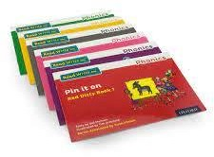
By moving through the carefully designed stages (or colours) of books which consolidate the sounds learned at the right time, children will gain speed and confidence in their reading ability. As reading becomes more fluent, children begin to understand the stories they read and can enjoy the books.
At BFS Naples, children read each Read Write Inc. Storybook three times in small group guided reading sessions to support learning new speedy green words and more tricky red words, to investigate vocabulary and to build expression known as their ‘storyteller voice’.
Re-reading the same book helps children to become confident readers. Each time they re-read, they build their fluency/speed and comprehension. They love reading and want to read because they can read all of the words in the Storybook.
Children will also complete comprehension activities as part of each book to ensure they know word meanings and can find and retrieve information as well as give opinions about the story or link to other books they know or life experiences.
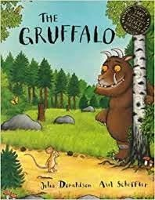
How can I support my child with reading?
Whilst your child is learning their Set 1 sounds we recommend you only read their ‘Reading for Pleasure’ books. This is a book that they are interested in and have chosen to enjoy with you. They can look at the pictures and spot letters or sounds that they know to build confidence but most importantly they should hear you read the book with expression in order to absorb the rich language and vocabulary within in and learn to love story time.
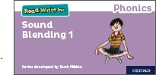
When your child is learning to blend, they will be given RWI Blending books. To help your child with these, ask them to try to ‘Fred Talk’ the word and blend it together … when they turn the page they will see if they were right! Encourage them to sound out carefully using pure sounds (not letter names) and give lots of praise and support for effort and success. You should also continue to read their ’Reading for Pleasure’ book and encourage them to spot any sounds, special friends or words they know to boost rapid identification by sight.
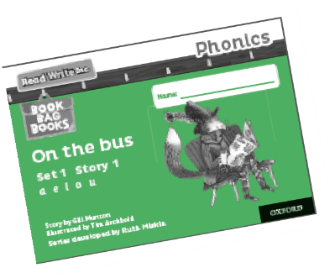
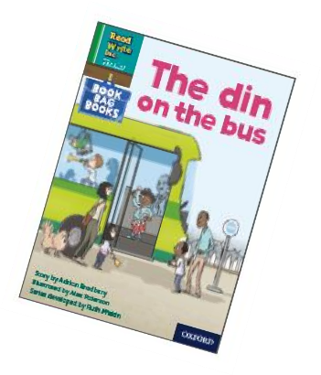
Once confident in blending, children will begin to receive two RWI books. One is the Black and White copy of the book they are reading in sessions at school. They will read this book three times in school so over the week they should become more confident and familiar with the story. This is done to build self-esteem and enjoyment in reading as well as to allow them to show off their reading skills to you!
The second book is a Book Bag Book. This will be unfamiliar to your child so read the opening instructions on the front page carefully before reading. These books allow children to apply their reading skills and are matched to the sounds they have been taught so far. These books should be read at home at least three times before being returned to school.
In the first read, your child will be focusing on reading each word individually and it may seem robotic. In this phase very little comprehension of the story is likely. In the second read, their word recognition will become quicker allowing a faster pace and better understanding of the story. In the third read, the speed should be much quicker and therefore the child is using more brain power to understand the story rather than on reading each word. This is the point when the story becomes meaningful and pleasurable and they can answer questions based on the content. There are questions at the end of the book to check understanding and promote discussion of the story. Please take the time to complete these activities as there are the early comprehension skills which are built upon throughout school.
Tips for listening to your child read:
- Do not read the book aloud before your child reads it to you.
- Ask your child to read the sounds and words before he or she reads the story.
- When your child reads the story, ask him or her to sound out the words that he or she can’t read automatically. Don’t allow your child to struggle too much. Praise your child when he or she succeeds.
- Read back each sentence or page to keep the plot moving. (Your child’s energy is going into reading the words not the story.)
- Do not ask your child to guess the word by using the pictures.
It is recommended that all reading should take place in a calm and quiet environment, a story before bed time or snuggled on the sofa without distractions of the TV etc. so the focus can purely be on the reading enjoyment. It should be relaxed and enjoyable and lots of praise should be given when children are successful. Please try not to get frustrated if your child is struggling as this is likely to put them off trying. Instead, encourage them to sound out words using Fred Talk and help them to blend and then praise for being successful.
Don’t forget that even if your child can read RWI books it is still important for them to regularly hear you read in order to learn expression. This will remove some of the pressure on them and also helps to improve their vocabulary levels as the books they listen to can be for any age. They will still be bringing home a ‘Reading for Pleasure’ book of their choice so make sure to include this in the weekly routine if you can. Children are not expected to read this book on their own. Audio books are also helpful and can be a good technique for settling and relaxing children before bed or as part of longer car journeys.

Tips for reading to your child:
