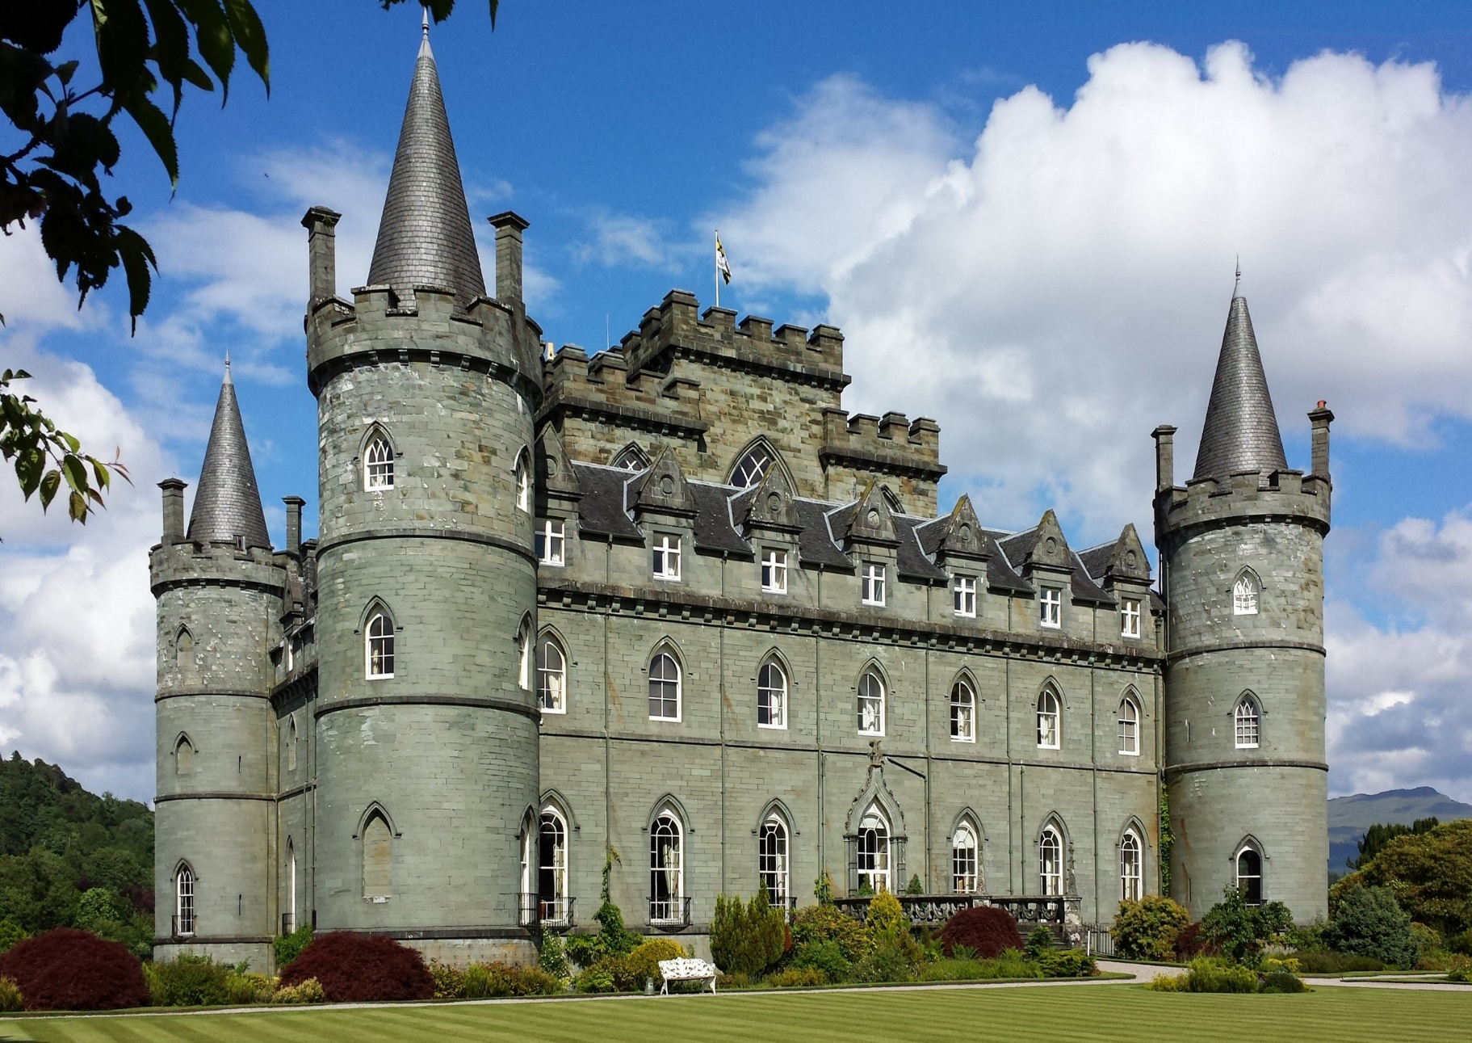

**Possible activities**

**RE**

Use creative ways to express their own ideas about the creation story and what it says about what God is like.

Identify two examples of religious believers caring for people

**PSHE**

Discuss the new learning behaviours:

The Reflective Squirrel and Independent Bear

Identify what a good friend means to me

To know who can help me in my school community

To recognise my qualities as a person and friend

Life Cycles

Changing me and coping with change

**Possible activities**

**ICT –** To use ScratchJr to create space themed sprites to perform a series of functions.

**Science –**

• Identify and compare the suitability of a variety of everyday materials, including wood, metal, plastic, glass, brick, rock, paper and cardboard for particular uses

• Explore and compare the differences between things that are living, dead, and things that have never been alive. Notice that animals, including humans, have offspring which grow into adults

**Geography -** Get a rocket’s eye view by visiting the NASA website to see and discuss images of Earth from space. Explore the Earth from above on mapping websites, identifying basic geographical features such as a sea, ocean, land, island, forest, city, lake and river.

**History** - Use information books and other available historical resources to find out about Yuri Gagarin (the first person to travel into space) or Neil Armstrong and Buzz Aldrin (the first men to land on the Moon). Record their findings in a simple non-chronological report or illustrated sentence, including why they are significant and their impact.

**Possible activities**

**DT**

Give the children construction kits and access to junk modelling materials to design and make a moon buggy. The children will then evaluate their models according to a set criterion.

**Music**

To create chants and songs with a space theme.

Children learn movements and create their own actions to perform rhymes and songs.

**Knowledge and Understanding of the World**

**(Geography, History, Science, ICT)**

**ICT**

**We are astronauts -** programming onscreen

• plan a sequence of instructions to move sprites in ScratchJr

• create, test and debug programs for sprites in ScratchJr

• work with input and output in ScratchJr

• use repetition in their programs

**•** design costumes for sprites.

**Science**

Uses of materials

Living things

**Geography**

• Use basic geographical vocabulary to identify and describe physical features, such as beach, cliff, coast, forest, hill, mountain, sea, ocean, river, soil, valley and vegetation.

• Use simple directional and positional language to give directions, describe the location of features and discuss where things are in relation to each other.

**History**

• Order information on a timeline.

• Understand the term significant and explain why a significant individual is important.

**Possible activities**

Use varying speeds when running

Explore footwork patterns

Explore arm mobility

Explore different methods of throwing

Complete a circuit that includes activities learned throughout the year

Explore running at different speeds

Improve agility, balance and co-ordination

Learn skills for striking and fielding games.

Practise basic striking, sending and receiving

**Physical Development**

**(PE, growth and health)**

**Sports**

Active Athletics

Throwing and catching

**Fitness**

Cool core (Strength)

Fitness Frenzy

**Personal, Social and Emotional Development**

**(RE, PSHE)**

**RE How should we care for others and the world and why does it matter?**

**•** Re‐tell Bible stories and stories from another faith about caring for others and the world

• Identify ways that some people make a response to God by caring for others and the world

**PSHE – Jigsaw Topic:**

* Relationships
* Changing Me

**Mathematical Development**

**(Number, Geometry and Measurement)**

**Year 1:**

* Multiplication and division
* Fractions
* Position and direction
* Place Value – within 100
* Money
* Time

**Year 2:**

* Fractions
* Time
* Statistics
* Position and direction

**Possible activities**

* To learn to tell the time on an analogue/digital clock.
* Find fractions of shapes and amounts
* To know the points of the compass and follow simple directional commands
* Using iPads/IT Games to learn multiplication tables and inverse operations
* Create tables of information and simple graphs.

**Possible activities**

English

* Children will write a double page spread of information which includes an introduction, a flap with sentences providing further information for the reader and a flap which poses and answers a question.
* To perform some poems as part of the class/group for an audience, using expression, intonation and rhythm appropriately.
* To write their own poem based on a model from the text.
* To write a character description based on the story Beegu.
* Daily phonics/ spelling and reading sessions – interactive activities available.
* Spelling rule activities taught and explored as part of the lesson and separately to embed understanding.
* Children will be encouraged to read more for pleasure to gain a broader vocabulary to support writing.
* Daily handwriting.

Italian

* The children will learn basic vocabulary and phrases. They will be encouraged to listen to others and respond to questions posed by the teacher and pupils. The children will learn a range of songs to further develop their vocabulary and understanding.

**Creative Development**

**(Art, DT, Music, Drama)**

**DT – Making a Moon Buggy**

**•** Name and explore a range of everyday products and describe how they are used.

• Use wheels and axles to make a simple moving model.

• Construct simple structures, models or other products using a range of materials.

• Select from and use a range of tools and equipment to perform practical tasks

• Explain how closely their finished products meet their design criteria and say what they could do better in the future.

**Music – Travel**

• Combining voices, movement and instruments to perform a chant and a song

• Keeping a steady beat on instruments

• Creating word rhythms

• Performing word rhythms with movement

**Number**

• Recognising and developing a sense of steady beat through using voices and body percussion

• Identifying and performing changes in tempo

• Learning to play percussion with control

**Enrichment**

Visit the Science Museum to see the Planetarium and Spazio (Al Futuro) Exhibit

**Moon Zoom! Ferrari Class Topic Web Summer 2023**

***The countdown has begun. Are you ready for blast off?***

This half term, we’ll travel through space to learn about the Solar System. We’ll investigate an alien crash site, write an incident report and try to find the aliens who have landed. Where could they be? We’ll make models of the Solar System and design spaceships, space buggies and space-related toys. Books and photographs will help us to learn about the first lunar landing and the astronauts who venture into space. Floor robots will be programmed to move around an alien landscape, and we will compose space sounds and dances. We’ll also explore satellite images, investigate rockets and use ICT to communicate our ideas and present our work.

**At the end of our project, we’ll share our learning in a variety of different ways. We’ll read our exciting science-fiction stories aloud, sing space-themed songs and create an exhibition of our space models. It will be out of this world!**

**Communication, Language and Literacy**

**(Speaking & Listening, reading, writing, MFL)**

**Texts: Look Inside Space (non- fiction) Zim Zam Zoom (Poetry) and Beegu (fiction)**

English

* Explore a variety of text including fiction, non-fiction and poetry.
* Read and write common exception words
* Make predictions in stories.
* Independently compose sentences.
* Use full stops and capital letters.
* Use conjunctions – and, but, so, because, when, if
* Begin to make specific word choices
* Use and apply taught spelling rules
* Have an understanding of word class terminology.
* Form upper and lower case letters correctly and begin joining

Italian

* Listen attentively, understand and respond to spoken language.
* Ask and answer questions
* Explore patterns and sounds of the language through songs and rhymes.