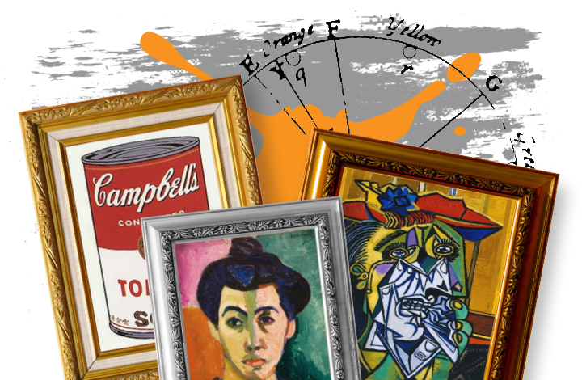
Create a piece of art inspired by a famous artist.

Perform ‘A Midsummer Night’s Dream.’
Possible Activities

R.E.
We will compare how art and holy buildings matter as expressions of devotions to God in the Muslim and Christian faiths. We will also investigate how they practise generosity and charity.

PSHE
We will learn about the changes to the body in boys and girls during puberty. We will explore how babies develop from conception to birth. We will learn strategies to develop our own self-esteem.

Possible Activities
History
The children will look back in history and create a timeline of the major art movements

Science – Investigations

We will plan and set up our own fair tests. We will collect the data, display our findings and draw conclusions from the information we have collected.
Possible Activities

Maths
We will cover the following areas of maths over the half term:

Statistics
Interpreting graphs, charts and tables and representing data in different ways.

Geometry: Shape
We will explore 2D and 3D shapes through reasoning and problem solving. We will use protractors and calculate missing angles.

The children will also continue to evaluate and develop their mental arithmetic skills.

Possible Activities
English

Kensuke’s Kingdom by Michael Morpurgo
We will read this exciting adventure text and complete both fiction and non-fiction writing in response to the events and themes in the book. We will focus on editing skills to ensure our writing is the best it can be.
Framed by Frank Cottrell Boyce
We will read extracts from the novel 'Framed', which features National Gallery paintings. We will create Newspaper reports and descriptive writing linked to themes and paintings described in the text.

Italian
Continue to learn Italian with Kelia in our weekly lesson. Focus on speaking and listening skills.
Possible Activities
Art
Children will study the great art movements of the past including impressionism, surrealism, and expressionism. They will learn about some of the key artists of these periods.
Once they have learnt about the background to the movement, they will create pieces of art ‘in the style of’.
Music/Drama
We will learn the songs and parts in order to perform the play, ‘A Midsummer Night’s Dream’.

Possible Activities

Striking and Fielding
We will play cricket and rounders games to develop our throwing and batting skills in the context of fun team games.

Fitness Frenzy

I wonder...

Does art have to be a picture?
Possible Activities
We will create an animation of a cartoon character talking using the app Keynote

Mathematical Development
(Fractions, Decimals and percentages)
Year 5
- Solve comparison, sum and difference problems using information presented in a line graph.
- Complete, read and interpret information in tables, including timetables.
- Identify 3-D shapes and 2-D shapes from representations.
- Draw angles and measure them in degrees.
- Identify angles at a point, on a straight line and in a whole turn.
Year 6
- Interpret and construct pie charts and use these to solve problems.
- Draw 2-D shapes using given dimensions.
- Illustrate and name parts of a circle.
- Compare geometric shapes based on their properties and sizes.
- Find unknown angles in triangles, quadrilaterals and regular polygons.
Communication, Language and Literacy
(Speaking & Listening, reading, writing, MFL)

English
- Read and discuss a wide range of fiction and check what they have read, discussing their understanding and exploring the meaning of words in context.
- Plan writing identifying the audience and purpose of the writing, selecting the appropriate form.
- Draft by selecting appropriate grammar and vocabulary to enhance meaning.
- Evaluate by assessing the effectiveness of their own and others’ writing.
Italian
- Read a few words, phrases and sentences, use visual clues and dictionaries to find the meaning of words.

Physical Development
(PE , growth and health)
- Throw and catch under pressure.
- Practise effect batting control.
- Play in a tournament and work as a team.
- Perform and devise a sequence of movements to music.
- Perform others’ sequences with control and balance.
Creative Development
(Art, D&T, Music, Dance, Drama, Role Play)

Art
- Learn about great artists in history and understand the historical and cultural development of their art forms.
- Create sketch books to record their observations and use them to review and revisit ideas.
- Improve their mastery of art and design techniques, including drawing and painting with a range of materials.

Music/Drama
- Play and perform in ensemble contexts using their voice with control and expression.

Knowledge and Understanding of the World
(Geography, History, Science)
History/ geography
- Use sources of evidence to deduce information about the past.
- Describe the main changes in a period of history. Science
- Select appropriate ways to answer science questions using different scientific enquiry.
- Observe changes over different periods of time.
- Carry out comparative and fair tests.
- Draw conclusions based on their data and observations using their scientific knowledge and understanding to explain their findings.
Personal, Social and Emotional Development.
(RE, PSHE, Citizenship, SEAL)
RE – Is it better to express your religion in arts and architecture or in charity and generosity?
- Describe and make connections between examples of religious creativity.
- Suggest reasons why some believers see generosity and charity as more important than buildings and art.
- PSHE – Changing Me
- I know how to develop my own self esteem.
- I can explain how girls’ and boys’ bodies change during puberty.
- I can describe how a baby develops from conception to birth.
- I can express how I feel about my self-image and know how to challenge negative ‘body-talk’.

Lamborghini Spring Term 2: Gallery Rebels
Colours collide, melting together on the canvas: an impression of light, a rage of red, a lobster perched on a telephone. Come and find out about the bizarre and eccentric minds of the gallery rebels. Art can be an act of rebellion. Can you change the world with a paintbrush, a thought, or an idea? Dream the dream, or show us your nightmares. What do you see? Watches melting? Wheels spinning? A shark in a box? Can you express yourself without words? Well, a picture paints a thousand of them. Paintbrushes and sketchbooks at the ready. Let’s make art.
Computing
Animation
- Choose and create different types of animations to best explain learning.
- Create videos using a range of media - green screen, animations, film and image.

