Companion projects
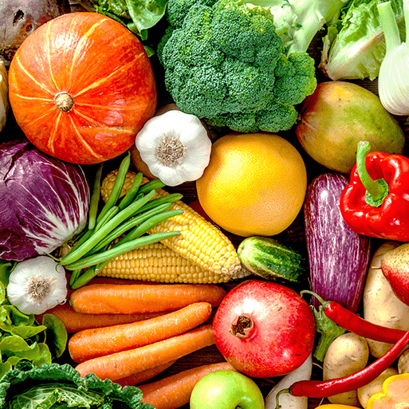 Chop, Slice Mash
This project teaches children about sources of food and the preparatory skills of peeling, tearing, slicing, chopping, mashing and grating. They use this knowledge and techniques to design and make a supermarket sandwich according to specific design criteria.
Street View
This project teaches children about artwork depicting streets and buildings and focuses on the work of the American pop artist, James Rizzi. They create a 3-D mural based on Rizzi's work.
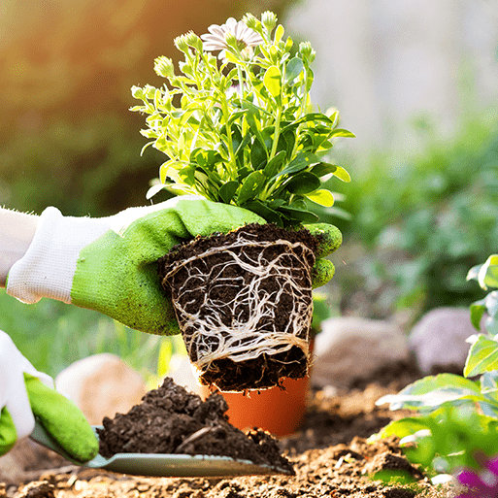 Plant Parts
This project teaches children about wild and garden plants by exploring the local environment. They identify and describe the basic parts of plants and observe how they change over time.
Animal Parts
This project teaches children about animals, including fish, amphibians, reptiles, birds, mammals and invertebrates. They identify and describe their common structures, diets, and how animals should be cared for.

