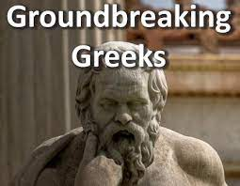 | Lamborghini Class Topic Home Learning Spring Term Topic Title: Groundbreaking Greeks  These are your ideas for our topic home learning this term. The suggestions are all related to our Ancient Greek topic and cover lots of subject areas.  Each week, you need to choose and complete at least one activity from the boxes below.
Practial learning ideas | Maths, science and geography learning | Creative learning ideas | Reading and writing ideas
Create your own mini-Olympics.  Draw a plan of the activities you will complete and take photos of the events.  Create a table to record your ‘personal best’ at each activity. | Draw a map of Ancient Greece.  Label the seas surrounding Greece and plot on the key cities and landmarks. | Make a Spartan helmet or design a shield. | Research the Ancient Greek alphabet. Write out the letters and have a go at writing some words in Ancient Greek.
Build a Greek temple using whatever materials you have available at home.  Make labels to show the key features of the building.  Bring the building to school or take photos of it if it is too big. | Research the life and work of Greek mathematicians Archimedes or Pythagoras.  Use the information you find to write a short biography about them. | Make your own ‘Greek Gods’ Top Trumps cards. | Turn any Greek myth into a comic strip. Research the plot and use speech bubbles and captions to tell the story.
Make a Greek food dish and write out the recipe.  Take photos of what you make and write a review of it. | Research how many medals were won by different countries in the 2020 summer Olympic games held in Japan. Create a table to record the information. Find the medal total for each country. | Create a picture or image of a Greek God. Provide facts and information about them. | Make an information leaflet about Ancient Greece. What is there to see? Where could you travel? What could you visit?

