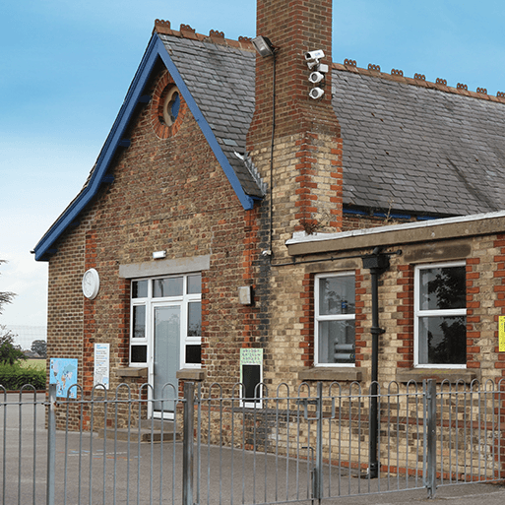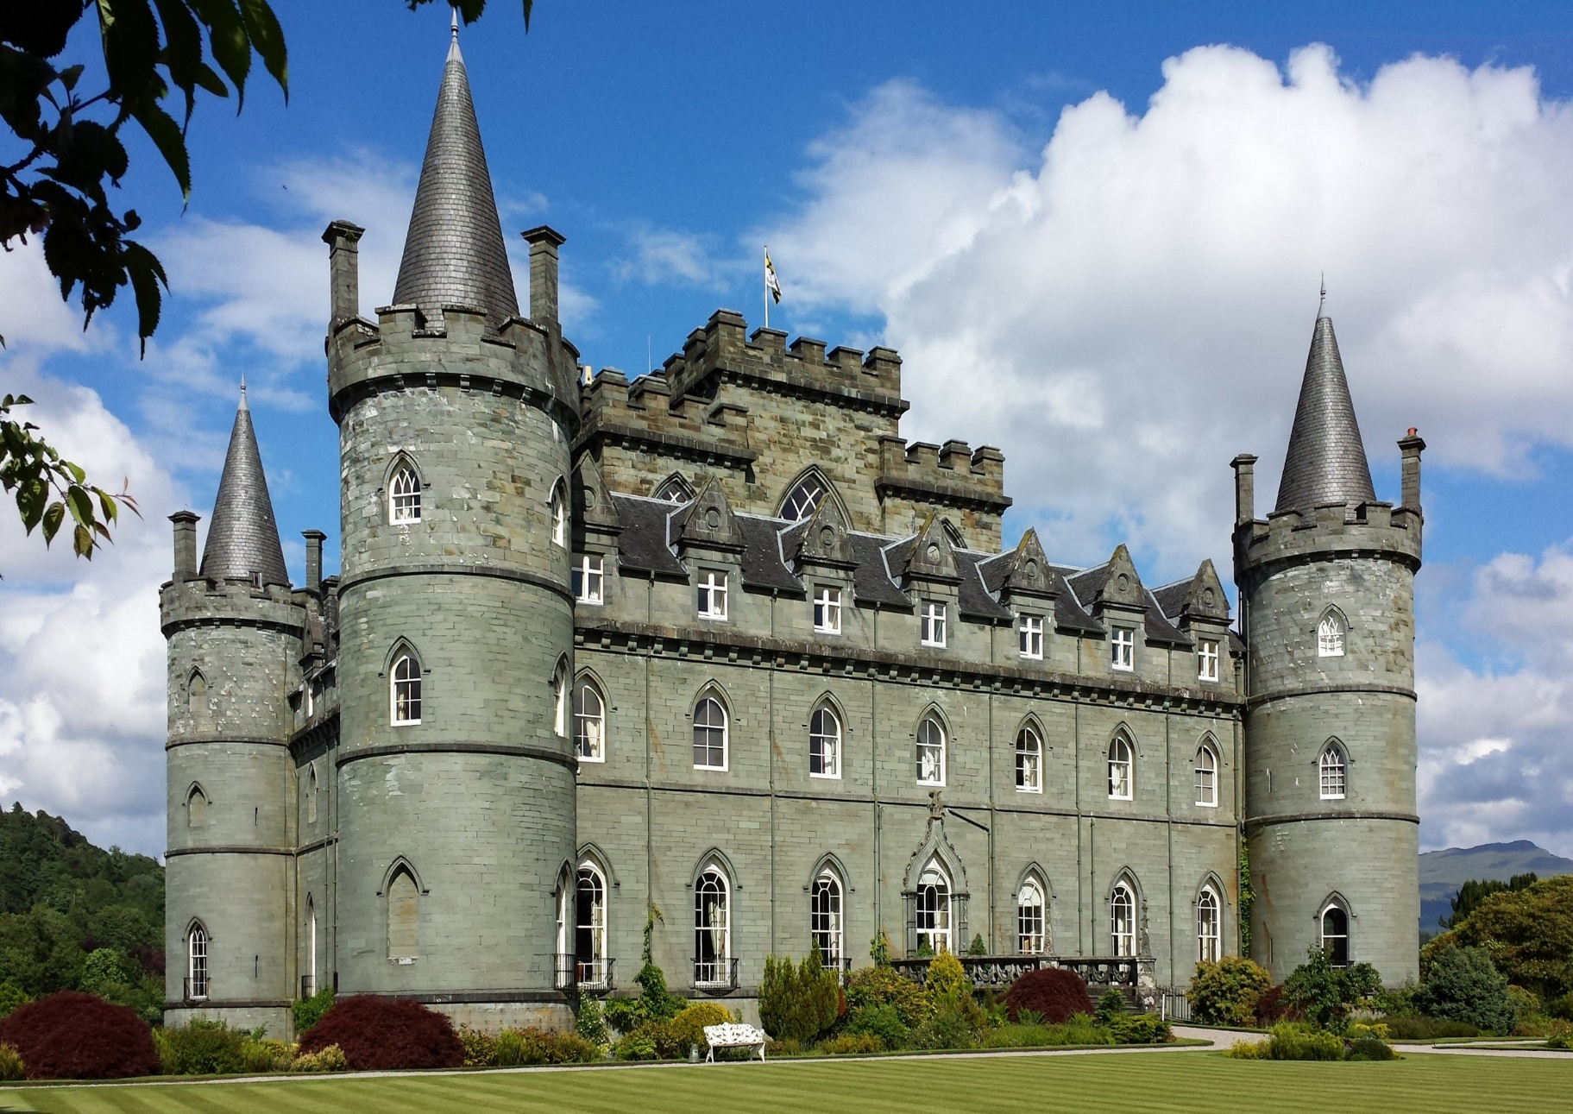

**Communication, Language and Literacy**

**(Speaking & Listening, reading, writing, MFL)**

(Poetry: Performance poem: A First Poetry Book by Pie Corbett and Gaby Morgan Non-Fiction: Information text Creature Features by Natasha Durley. Fiction: Short story How to hide a lion at school by Helen Stephens

Non- Fiction: Write in role about Victorian School Day)

**English**

Discussing the sequence of events in books and how items of information are related (Y2)

Being introduced to non-fiction books that are structured in different ways. (Y2)

Discuss word meanings, linking new meanings to those already known (Y1).

Link what they read or hear being read to their own experiences (Y1).

Draw on what they already know or on background information and vocabulary provided by the teacher (Y2).

Discuss and clarify the meaning of words, linking new meanings to known vocabulary (Y2).

Sequence sentences to form short narratives (Y1).

Write narratives about personal experiences and those of others

Begin to punctuate sentences using a capital letter and a full stop, question mark or exclamation mark (Y1).

Learn how to use both familiar and new punctuation including full stops, capital letters and exclamation marks.

Make the correct choice and consistent use of present tense and past tense throughout writing (Y2).

Use the progressive form of verbs in the present and past tense to mark actions in progress (e.g. *she is drumming, he was shouting*) (Y2).

subordination (using ‘when’, ‘if’, ‘that’, or ‘because’) and co-ordination (using ‘or’, ‘and’, or ‘but’).

**MFL – Italian**

Understand and retell an Italian traditional story –La Befana. and know the traditions that go with the celebration of La Befana.

Name parts of the face

Begin to learn the names of some animals

Learn about Carnevale, the story of Arlecchino and make Carnevale masks

Know the names of some of the rooms and furniture inside a house

Understand Italian Easter traditions

**Creative Development**

**(Art, DT, Music, Drama)**

**Art**

**Street View**

This project teaches children about artwork depicting streets and buildings and focuses on the work of the American pop artist, James Rizzi. They create a 3-D mural based on Rizzi's work.

**DT**

**Chop, Slice and Mash**

This project teaches children about sources of food and the preparatory skills of peeling, tearing, slicing, chopping, mashing and grating. They use this knowledge and techniques to design and make a sandwich according to specific design criteria.

**Music**

**Machines –** Creating and responding to vocal sounds

**Seasons** – Identifying and responding to changes in pitch

**Patterns** - Understanding how music, dance and drama can combine in storytelling

**Travel** - Exploring and controlling dynamics (volume), duration and timbre with voices, body percussion and instruments

**Physical Development**

**(PE, growth and health)**

**Sports**

**Skip to the beat** (Skipping)

**Brilliant Ball Skills** (Throwing, catching, kicking and early games skills)

**Fitness**

**Ugly Bug Ball dance** (develop a range of dance movements)

**Gym fit circuits** (Practise a range of gymnastic skills through a series of circuits and with increased accuracy.)

**Personal, Social and Emotional Development**

**(RE, PSHE)**

**RE**

**What can we learn from scared books?**

Recognise that sacred texts contain stories which are special to many people and should be treated with respect.

**What does it mean to belong to a faith community?**

Recognise symbols of belonging from their own experience, for Christians and for Jews or Muslims

**PSHE – Jigsaw Topic:**

**Dreams and goals** In this unit children will learn to set a goal and how to achieve it.

**Healthy Me** In this unit the children will learn how to make healthy lifestyle choices.

**Knowledge and Understanding of the World**

**(Geography, History, Science, ICT)**

**ICT**

**Animation – Stop motion**

Create a simple stop motion animation.

Explain how an animation/flip book works

Write algorithms for everyday tasks

Use logical reasoning to predict the outcome of algorithms

Understand decomposition is breaking objects/processes down

Know how to debug algorithms

**Programming – Simple Algorithms with Daisy the Dino**

Understand what algorithms are

Write simple algorithms and understand the sequence of algorithms is important

Create a simple program on a digital device, e.g. BeeBot or tablet

Use sequence in programs

Locate and fix bugs in a programme

**Science**

**Plant Parts**

This project teaches children about wild and garden plants by exploring the local environment.

They identify and describe the basic parts of plants and observe how they change over time.

**Animal Parts**

This project teaches children about animals, including fish, amphibians, reptiles, birds, mammals and invertebrates. They identify and describe their common structures, diets, and how animals should be cared for.

**Geography**

Use aerial photographs and plan perspectives to recognise landmarks and basic human and physical features; devise a simple map; and use and construct basic symbols in a key.

Use basic geographical vocabulary to refer to key human features, including: city, town, village, factory, farm, house, office, port, harbour and shop.

Use simple fieldwork and observational skills to study the geography of their school and its grounds and the key human and physical features of its surrounding environment.

Breadth Understand the processes that give rise to key physical and human geographical features of the world, how these are interdependent and how they bring about spatial variation and change over time.

**History**

**School Days (Victorians)**

Learn about changes within living memory. Where appropriate, these should be used to reveal aspects of change in national life.

Learn about events beyond living memory that are significant nationally or globally.

Learn about significant historical events, people and places in their own locality.

Learn about the lives of significant individuals in the past who have contributed to national and international achievements. Some should be used to compare aspects of life in different periods.

**Mathematical Development**

**Year 1:**

* **Place Value –** within 20
* **Addition and Subtraction** – within 20
* **Place value** – within 50
* **Measurement** – length and height
* **Measurement –** mass and volume

**Year 2:**

* **Measurement** – money
* **Multiplication and Division**
* **Measurement** – length and height
* **Measurement –** mass, capacity and temperature

**Enrichment**

In role, Victorian Classroom experience.

**Ferrari Class Topic Web Spring 2024**

**SCHOOL DAYS**

This project teaches children about their own school and locality, both today and in the past. They compare schooling in the **Victorian era** to their experiences today.