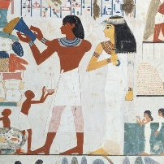 | Maserati Class Topic Home Learning Topic Title: Ancient Egypt  These are your ideas for our topic home learning over this term. The suggestions are all related to our Ancient Egyptian topic and cover lots of subject areas.  If you would like to do something different related to the topic, that’s fine!  Each week, you need to choose and complete at least one activity from the boxes below.
Top Trumps  Make a set of ‘Top Trumps’ card about Egyptian Gods and Goddesses.  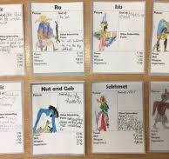 | Diorama of a Burial Chamber  Draw a sketch of your chamber and then make all the pieces inside a shoe box.  You could include: sarcophagus, canopic jars, wall paintings, food, clothing and jewellery, oils and ointments, weapons and games. | 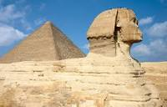  Can you make a model of a Sphinx? | Egyptian Life  Make an Egyptian Fan.  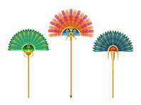
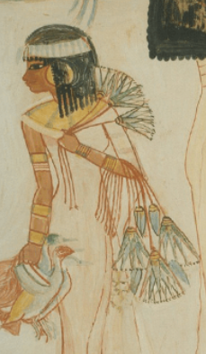 | Cooking  Make an Egyptian food dish and write the recipe. Take photos of what you make and write a review of it. | Decorative Collar  Desing and make a decortive collar, add richness and colour to palin clothes. (You could use half a paper plate)  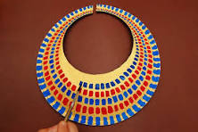 | 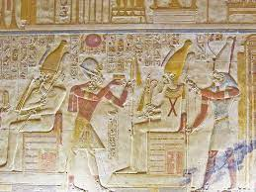
The Pyramids  Egypt’s great pyramids were tombs for some of the Pharaohs and their families. The burial chamber was filled with things the Pharaoh would need for the afterlife. Can you make a 3d Pyramid?  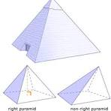 | Canopic Jars  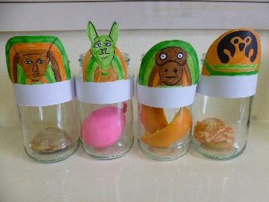  Can you make your own Canopic jars? | Make a head of the Goddess Bastet  Re’s daughter, a cat called Bastet, was the goddess of the harvest.  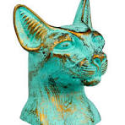 | Temple  Egyptian temples were huge. They were built of stone because they were meant to last forever.  